THE UNITED STATES NAVAL ACADEMY GLEE CLUB

THE UNITED STATES NAVAL ACADEMY GLEE CLUB is comprised of The United States Naval Academy MEN’S GLEE CLUB, which has achieved prominence as one of the world’s premier men’s choruses, and The United States Naval Academy WOMEN’S GLEE CLUB, which is the only all-female military choral ensemble in the world. Appearances on network television include The Kennedy Center Honors (CBS), The Today Show (NBC), The Early Show (CBS), Christmas in Washington (NBC and TNT), Good Morning, America (ABC), and countless regional and local television stations.

The Glee Clubs often perform masterpieces of choral-orchestral literature combining with the nation’s leading orchestras. In addition to the Academy’s annual presentation of Handel’s Messiah, the Glee Clubs are featured each year on the Naval Academy’s Distinguished Artist Series. Recent performances have included “A Night at the Opera,” Orff’s Carmina Burana, Requiems by Brahms, Dvorak, Faure, Mozart and Verdi, Haydn’s Creation, Beethoven’s Ninth Symphony, Vaughan-Williams’ A Sea Symphony, Stravinsky’s Symphony of Psalms, Mahler’s Symphony No. 2, among many others. Recent orchestral collaborations away from USNA include performances with the Minnesota Orchestra, Boston Pops, Dallas Symphony Orchestra, Charlotte Symphony, Phoenix Symphony, Columbus Symphony, Nashville Symphony, Portland Symphony, Winston-Salem Symphony, Jacksonville Symphony, Memphis Symphony, and Rochester Philharmonic.

In the past decade alone, the Glee Clubs have performed extensively throughout the US and abroad including Chile, Argentina, Brazil, and several European Tours with performances at St. Peter’s in the Vatican, cathedrals in Brussels, Wells, Winchester, Salisbury, and St. Paul’s in London. Recent domestic tours have taken them to Arizona, California, D.C., Florida, Georgia, Hawaii, Illinois, Michigan, Minnesota, Nevada, New Mexico, New York, North Carolina, Pennsylvania, Puerto Rico, South Carolina, Tennessee Texas, Virginia and Washington. Ensembles have been seen performing in San Diego’s Copley Symphony Hall, New York’s Carnegie Hall and Avery Fisher Hall, Washington’s Kennedy Center, and Dallas’ Morton Meyerson Symphony Center and many of the nation’s great concert halls.

Additional recent notable appearances include the dedication ceremony of the Pentagon Memorial (9/11), the Ronald Reagan Freedom Award, the Commissioning Ceremony and Gala for the George H. W. Bush Aircraft Carrier (CVN-77), and the Presidential Inaugural Concert “We Are One” performed on the steps of the Lincoln Memorial for a live audience of over half a million and an internationally televised audience, the nationally televised JFK 50th Commemorations in Dallas and Boston, a performance at the White House, numerous concerts at the Academy, and participation in a nationally televised Kennedy Center Honors.

The ability to perform in such a variety of public venues undoubtedly assists in the recruitment of potential candidates who otherwise would not be exposed to the incredible opportunities offered by attending the Naval Academy and presents our midshipmen to the public at the highest level of professionalism to audiences around the globe as ambassadors for the United States and its Armed Forces.

It is with honor, pride, and distinction that the Glee Clubs represent the United States, the Navy and Marine Corps, and the United States Naval Academy.

Additional information can be found by visiting our website at www.usna.edu/music.

The United States Naval Academy’s MUSICAL ACTIVITIES DEPARTMENT is the primary source of Fine Arts education for the Brigade of Midshipmen. Throughout the Academy’s 175 year history, Musical Activities have played a crucial role in the lives and development of midshipmen who have found academic enrichment, leadership opportunities, inspiration, and camaraderie in its varied offerings. In a single year, Music Department ensembles will perform for the Brigade and thousands of concert attendees throughout the nation and around the world. An estimated 150,000 people will see a live performance – millions when televised. For the midshipmen, the various ensembles provide an invaluable resource during their evolution to become leaders. In addition to being exposed to military and world leaders, midshipmen gain strength and confidence by performing for senior officers and their classmates. They are continually taught to strive to work together as an ensemble to create something greater than themselves. They are taught to embrace the finest qualities the Naval Academy strives to engender in its future leaders.

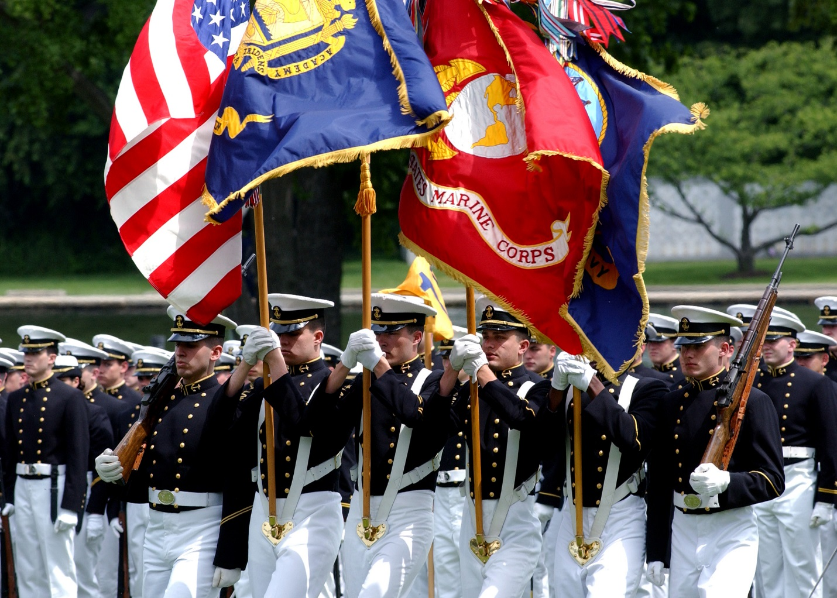

THE UNITED STATES NAVAL ACADEMY was founded in 1845 in Annapolis, Maryland. The history of the Academy has often reflected the history of the United States itself. As the U.S. Navy has moved from a fleet of sail and steam-powered ships to a high tech fleet of nuclear-powered submarines and surface ships as well as supersonic aircraft, the Academy has changed also. The Naval Academy gives young men and women the up-to-date academic and professional training needed to be effective naval and marine officers in their assignments after graduation. Every day, as the undergraduate college of the naval service, the United States Naval Academy strives to accomplish its mission to develop midshipmen “morally, mentally, and physically.”

Moral and ethical development is a fundamental element of all aspects of the Naval Academy experience. As future officers in the Navy or Marine Corps, midshipmen will someday be responsible for the priceless lives of many men and women and multi-million dollar equipment. From their first day through graduation, the Naval Academy's Officer Development Program is a four-year integrated continuum that focuses on the attributes of integrity, honor, and mutual respect.

Every midshipman's academic program begins with a core curriculum that includes courses in engineering, science, mathematics, humanities and social science. This is designed to provide a broad-based education that will qualify the midshipmen for practically any career field in the Navy or Marine Corps. At the same time, our majors program gives them the opportunity to develop a particular area of academic interest.

The Academy also provides professional and leadership training. We don't just teach the students about life in the Navy and Marine Corps. After four years at the Naval Academy, the life and customs of the naval service become second nature. The professional classroom studies are backed by many hours of practical experience in leadership and naval operations, including assignments with Navy and Marine Corps units.

Just as the Naval Academy promotes the moral and mental development of midshipmen, so also must it fulfill its responsibility for each midshipman's physical development. Every midshipman has a wide variety of athletic choices, as well as the required physical education curriculum. The primary goal of the physical education curriculum is fitness, which is so vital for midshipman health, personal appearance and well-being.

Upon graduation, every midshipman becomes a commissioned officer in the United States Armed Forces serving to protect our nation and better the world at large.

