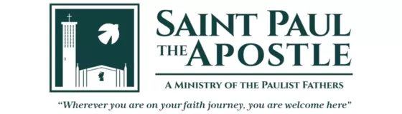
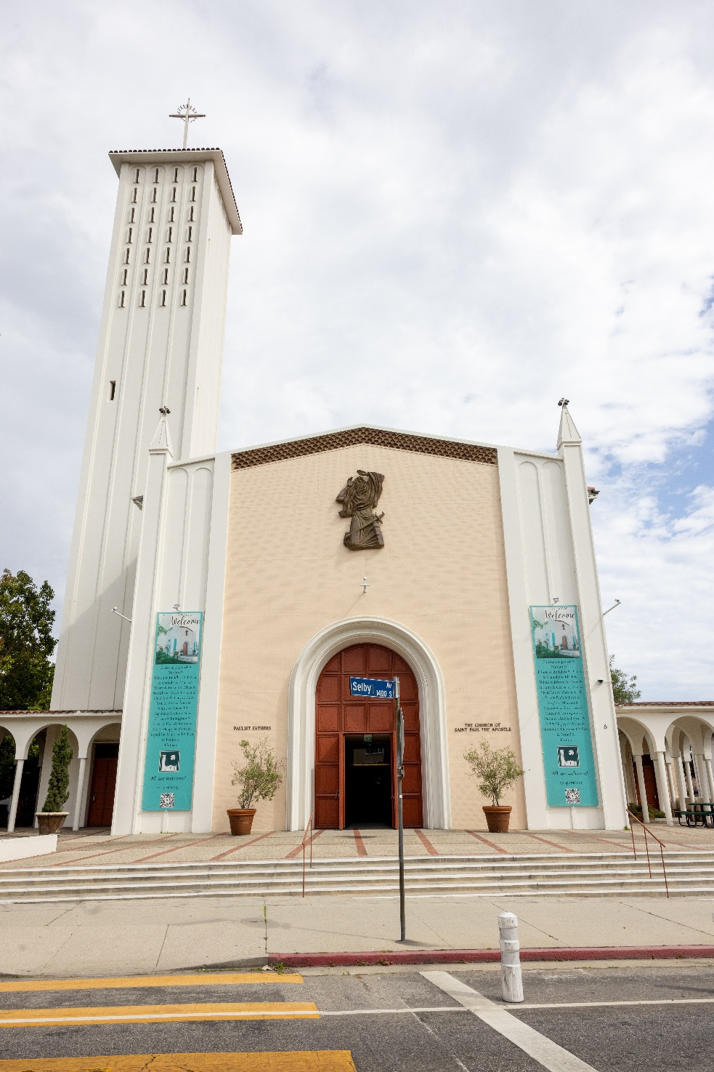
2025-2026 Altar Server Handbook
St. Paul the Apostle Catholic Community

Table of Contents
Introduction 1
Why Be an Altar Server? 2
You learn why we do everything in the Liturgy. 2
To provide an important and meaningful service to the community here at SPA. 2
You get fully involved in the Mass and get more out of it. 2
You will make some great friends. 3
You learn some fantastic life skills. 3
You become more involved in the community. 3
Dress Code for Altar Servers 3
Altar Server Expectations 4
Altar Server Sign-up Procedures 5
Altar Servers Step-by Step Guide 6
BEFORE MASS: 6
ENTRANCE PROCESSION 6
INTRODUCTORY RITES 7
LITURGY OF THE WORD 8
LITURGY OF THE EUCHARIST 10
OFFERTORY COLLECTION/PROCESSION 10
PREPARATION OF THE ALTAR 10
PREPARATION OF THE GIFTS 12
EUCHARISTIC PRAYER 13
COMMUNION 15
CONCLUDING RITES 16
RECCESION 17
AFTER MASS 17
Reminders 18
Appendix 1. Basic Liturgy Knowledge for Altar Servers 20
Order Of Mass 21
Introductory Rites 21
Liturgy of the Word 22
Liturgy of the Eucharist 23
Communion Rite 24
Concluding Rites 25
Appendix 2. Names of Places and Things 26
Appendix 3. Altar Server Agreement 43
Appendix 4. Altar Server Shoe Examples 45
Appendix 5. Sign Up Genius: How to Sign up and Manage Your Signups 47

Introduction

Altar servers perform an especially important and needed role in our liturgical services. This role includes assisting the celebrant and other ministers so that the liturgy can be conducted with grace and reverence. It enables the celebrant congregation to focus on leading the Mass through word and prayer. The activities of the altar server include carrying the cross, carrying lighted candles, holding books, handling vessels and other liturgical items (such as the thurible and incense boat), assisting with weddings, baptisms, conformations, funerals, etc. The humble service of an altar server helps to eliminate distractions and enable the other ministers to simplify their motions during liturgical services.
Altar servers are welcome members of the liturgy’s “team,” along with greeters/ushers, sacristans, musicians, priests, lectors, and Eucharistic ministers. All registered parishioners in 4th grade or older, including teens and adults are welcome to serve at St. Paul the Apostle.
Jennifer Kozakowski is the altar server coordinator. She is along-time parishioner having worshipped at the University Catholic Center at UCLA (1978-1994) and St. Paul the Apostle Parish (1994-Present). She and her husband, Frank, have been married for 40 years and have two adult children who received all their sacraments at St. Paul the Apostle and graduated from the school. For years Jennifer managed all the ticket sales for the Fall Festival. In addition, she has served on the Parish Council, the Finance Council, the Liturgy Committee, as a Sacristan, Eucharistic Minister. She also serves as the Teen Confirmation Coordinator. For over 40 years has served in a variety of executive roles in health care, most recently with Providence St. Jospeh Health. She currently serves as the Chief Mission Integration Officer at Providence Little Company of Mary ministries in the South Bay, where (among other things) she is responsible for Ethics Committee and Consultation Service, as well as the formation of all employees, leaders, medical staff, and board members. She has earned a Bachelor of Science in Nursing, a Master of Nursing in Nursing Administration, and a Master of Public Health in Health Services Management, all from UCLA. In 2021, she completed a Master of Arts in Health Care Mission Leadership with emphasis in Theology and Ethics from the Neiswanger Institute of Bioethics at Loyola University, Chicago.

Why Be an Altar Server?
There are many benefits to being an altar server. Here are just a few:

You learn why we do everything in the Liturgy.

Sure, swinging the thurible (the incense thing) is fun but why is it that we do it? By becoming an altar server, you begin to learn these things, and it makes all the symbols of the Mass so much more understandable and interesting.

To provide an important and meaningful service to the community here at SPA.

There are lots of opportunities to provide community service. Providing service to your church and school community is a special service—a way of giving back and serving as a role model for others.

You get fully involved in the Mass and get more out of it.

When you start to understand why we do something you get so much more from it. More than this though, by serving at the altar you pay more attention to the whole Mass to help you remember where your part fits in. By focusing and understanding what’s going on, the Mass can then lead you into a much deeper relationship with God and you feel the impact of Mass far greater! This can help in your spiritual life and your relationship with God.

You will make some great friends.

By becoming an altar server, you’ll be meeting up with many of the same people every time you serve at Mass. With a wide range of ages and experiences, you’ll meet some fantastic people you might not meet anywhere else. As your friendship develops, you’ll end up having many friends who all share your faith, and this can lead to some brilliant conversations and great memories.

You learn some fantastic life skills.

Communication, teamwork, anticipating what needs to be done and doing it, punctuality, self-confidence, and the list goes on. Serving on the altar is a wonderful place to start building these skills. You’re supported by all your fellow servers, you have quite a large responsibly and rules to guide you. Even if you do something wrong, nobody in the congregation notices so it’s always a winning situation!

You become more involved in the community.

By taking up a responsibility at Mass, you start to recognize more people in the church in general. This slowly changes your experience of the church community, from a group of random people you stand next to at Mass, to a large and diverse family who you can meet and chat with every time you attend, which helps you feel truly at home in your church.

Dress Code for Altar Servers
Hair should be nicely groomed, and long hair should be secured completely away from the face when serving.
Male altar servers are required to wear dress slacks or dress shorts with plain, dark socks and black (preferred), brown, or tan dress shoes.
Female altar servers are required to either wear plain black (preferred), white, brown, or tan closed toe dress shoes or dress sandals with no heel or low heel that are quiet when walking. Plain, closed toe dress shoes are preferred for females. Be sure you can walk easily in the shoes. Please see Appendix 4. for altar server shoe examples.
Altar servers must not draw attention to their feet. Sneakers (athletic or tennis shoes of any style or color), flip flops, “blingy” shoes, high heels, boots, or any other distracting shoes are not allowed. Exceptions will be made for medical reasons or if a server is “walking on” and was not signed up to serve. However, as a server, please try and dress in accordance with dress code whenever possible when attending Mass—you never know when you might be asked to serve.
Altar servers may bring their dress shoes for altar serving with them into church and change their shoes in the Liturgical Ministries Sacristy.
Do not wear anything that will make noise and/or will be distracting, or that will cause you to have problems serving. Girls may wear “appropriate” earrings to serve.

While serving, vestments are white albs with colored cinctures to match the Liturgical Season.

Altar Server Expectations

- Attend Altar Sever Training Classes, Refresher Sessions, Practice Sessions, and as many social gatherings as possible.

- Altar Servers should not leave the sanctuary after the start of Mass for any reason except to use the restroom, illness, or when directed to do so by the priest, senior server, or MC.

- Serve at every Mass that you sign up for, or decide to have someone cover the Mass.

- Arrive at least 20 minutes before the Mass starts to get dressed and make sure that the Altar is prepared.

- Help set up. Make sure the candles are lit, bread, wine, water, towels, bowl, prayer book, and any other sacramentals are in their proper place.

- Check in with Celebrant Priest or Altar Server Coordinator if present for any special instructions.

- Perform the duties assigned during the Mass in the prescribed orderly manner.

- Maintain a prayerful posture during all times in the Sanctuary (if you are not doing something your hands should be folded in your lap or clasped at your chest)

- After the Mass, offer to help to clean up and set up for the next Mass.

- Be quiet and respectful when on the altar—remember you are role models.

- Be attentive and respond immediately when the priest asks for help.

- Make sure that your cincture is returned to the closet hanging up—and place the alb in the gray wicker hamper when finished.

- Serve at least 4 times in a quarter, 2 of which are not at the 9:30 Mass.

- Get a substitute if you cannot serve for a Mass you signed up for.

- PAY ATTENTION. Please don’t fidget, play with, swing your cincture, or draw attention to yourself.

Altar Server Sign-up Procedures

- We will be using SignUpGenius to sign up for Masses.

- For the Regular Sign up: Please serve (at least) 4 Masses during each 3-month period. Two of your signups need to be at a Mass other than the 9:30 AM Mass. If you serve more than 4 times in a quarter, you may serve more at the 9:30. When signing up, please consider signing for a Mass that has no servers signed up or regularly does not have servers.

- For Shadow training, Christmas, and Triduum/Easter we will always send a notice when one of the special signups is available.

- If there are no slots available at the time you want to serve, please check back frequently, as slots will open due to conflicts/schedule changes.

- If you are not already signed up to serve on a given weekend, and plan to attend Mass, please check the sign-up form, and if there are unfilled slots, please consider signing up for the mass you plan to attend.

- When not on the signed up to serve at a mass, but attending mass, please always check in with the priest to see if there is a need for you to walk on. Sometimes there are last-minute cancellations, no shows, or a server is late, and we need a substitute.

- If your plans change after you sign up, please go back to the SignUpGenius to delete or switch your sign up.

- See Appendix 5. For more detailed instructions in using SignUpGenius.

Altar Servers Step-by Step Guide

BEFORE MASS:
- Arrive and be vested 20 minutes before the Mass begins. If you are not present and vested 10 minutes before Mass time, you may be replaced with a sub. If you arrive and the sub is already vested, the sub will serve. You may choose to serve in whatever role is available, or you may join the congregation. If you want to serve, even if you are late, if you get there before Mass, we will do everything we can to have you serve in some role.
  - Make sure the alb is the RIGHT SIZE, the bottom should be right above the tops of the shoes after the cincture is tied.
  - Tie the correct colored cincture around the waist. The knot should sit on the left hip. There is a diagram with instructions posted inside the door where the albs are hung. If you are not sure, please ask the priest celebrant.
- Check to make sure that everything is set up on the altar for the Mass. Light the candles on the altar and take the candles for the offertory procession and the cross to the back of the church.
- Make sure the gifts (ciborium with hosts and cruet with wine) are placed on the baptismal font before Mass starts.
- Make sure the Excerpts from the Roman Missal is on the Celebrant’s table and the Roman Missal for the Eucharistic Prayer is on the credence table behind the altar.
- Check with Celebrant to see how you can help with set up and if there are special instructions.
- Gather in the back of the church with the priest, deacon, lectors, thurifer, and anyone else who will be in the entrance procession.
- Make sure you talk to the other servers to figure out who will carry the candles and be the cross-bearer and book bearer. If you cannot come to agreement, please find the altar server coordinator, the celebrant, or Fr. Gil for assistance.
- Remember, candles are used in the opening procession and recession only if there are at least 3 servers. They are used at used at the Alleluia procession and proclamation of the Gospel if there are two or more servers. They may be used at the offertory procession if there are at least two servers to lead the gifts with both candles, but the celebrant may want just the cross to lead the gifts and the other server to prepare the altar, so please check with him before Mass.

ENTRANCE PROCESSION:
- The altar servers will line up. If there is incense, please note the thurifer leads the procession, followed by the cross bearer. If there is no incense, the order is as follows:
  - cross bearer and 2 candle bearers who stand right next to the cross shoulder to shoulder. The three move as a single unit.
  - Book bearer (carrying nothing)
- If there is only one server, the person will carry in the cross
- If there are only two servers, then no candles will be used in the entrance procession, and the bearer of the book will line up behind the cross-bearer.
- If there are three servers, then there is 1 cross bearer who holds the book as well and 2 candles.
- Once the choir has begun to sing, the altar servers will begin to process in.
- The Cross-Bearer holding the cross as high as possible and will turn to the right of the lectern without pausing and then head straight to the stands to place the cross in stand to the right of the altar as facing it and then proceed to stand in front of the small chair to the left of the celebrant’s chair. Please do not go to the center of the altar during the entrance procession.
- The candle bearers, if used, will stand right next to the cross. Please hold the candles high. The gold rim should be about at your forehead. If the candle bearers are different heights, one of you will need to adjust the height of your candle. As a single unit cross and two candles Proceed up the stairs with the cross going to the right of the lectern and without pausing or bowing place the candles in the stands on either side of the cross. They stay lit during the entire Mass. Proceed to the chairs behind the celebrant’s chair and stand.
- The book bearer then bows proceeds up the stairs to the three rings in the center of the altar and then to the chair to the right of the celebrant’s chair (it has the celebrant’s table next to it). Remain standing.
- WALK AT NORMAL SPEED, reverently.
- When the celebrant approaches the altar, he will bow and then come behind the altar to kiss it and then proceed to his chair. The other servers sit in chairs that will be behind the celebrant chairs. We will NO LONGER place chairs against the wall for servers to sit.
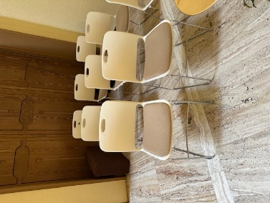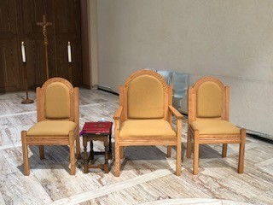
Candle Bearer Servers Book Celebrant Cross Bearer

INTRODUCTORY RITES

GREETING:
- The Celebrant will usually perform the greeting without the book. They each have their own style. The more you serve and pay attention the better you will know when to go and hold the book.
- The priest begins the Mass with the Sign of the Cross.
- The Priest begins with an introduction explaining the readings, or welcoming people to the Mass.
- The Celebrant asks us to recall our sins and ask God for forgiveness, we then respond with the “Lord Have Mercy, Christ Have Mercy, Lord Have Mercy.” This is called the Kyrie. Occasionally the priest will want the book for the Kyrie, but not usually. You can ask before Mass.
- The Gloria will then be sung but is always omitted during Advent, Lent, funerals, and weddings. During the last verse of the Gloria (or after the Kyrie if the Gloria is omitted), the book bearer grabs the Excerpts From the Roman Missal from the celebrant’s table and opens the book to the Collect (Opening Prayer), waiting for the cue, “Let us Pray…” at which time you move with the open book to hold for the celebrant.
- If you are tall, then stand to the right side of the celebrant and hold the book in your arm. If you are shorter and won’t block the priest and the book is too heavy to hold on your arm, hold the book on your chest, the top of the book resting just under your chin facing the priest.
- When the priest is done with the opening prayer, all reply, “Amen.” The book bearer returns the Excerpts from the Roman Missal to the celebrant’s table and all sit, and all servers sit in their chairs to listen to the first reading, the psalm, the second reading, and the Gospel.

LITURGY OF THE WORD
- First Reading-The Lector will come forward to read the First Reading from the lectern (No action is required by the altar servers).
- The psalm will be recited or sung at the lectern (No action is required by the altar servers).
- Second Reading-The Lector will come forward to read the Second Reading from the lectern (No action is required by the altar servers)
- Just as the second reading is ending, when the lector says, “The Word of the Lord,” the two candle bearers go and retrieve the candles from the stands next to the cross. If you are serving by yourself, you will retrieve one candle.
- They proceed to the small chair to right of the celebrant’s chair and wait for the priest or deacon to stand at the Alleluia Proclamation. If there is incense, the thurifer and boat holder will approach the celebrant while seated and kneel before him. Then the Alleluia begins. If no incense the priest will stand and proceed to the center of the front of the altar.
- During the Alleluia:
  - As soon as the priest or deacon moves toward the front of the altar, one candle steps in front to lead the procession to the altar and one candle is behind him, holding candles high. All three are moving in a single file line: candle, priest, candle. The one leading one stops in front of him and faces the altar, the priest stops and faces the altar to bow, and the candle behind stops and faces the altar. If there is only one candle, you step in front to lead the procession.
  - The priest or deacon will bow (candles do not bow) and approach the altar and remove the Book of Gospels from the stand and then turn to face the congregation. When he does this, the two candles on each side turn and face the congregation as well, holding candles high.
  - The priest or deacon will then turn right to proceed to the ambo (the pulpit, not the lectern). The candle to his right leads the way to the front of the ambo (the priest or deacon will go to the ambo). The procession is also single file candle, priest, candle. The first candle bearer and goes down to the left of the ambo (as you face it). The second candle stands to the right of the ambo (as you face it). The two candle bearers hold the candles high in FRONT of the ambo and turn to face one another. Be sure to hold the candles straight.
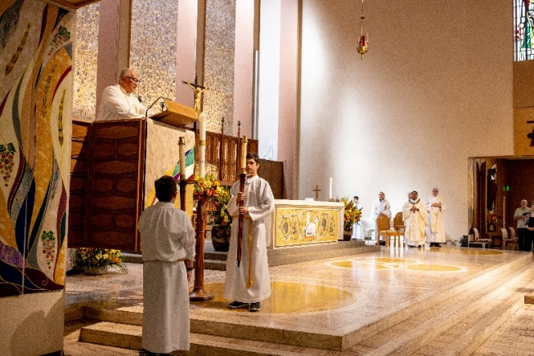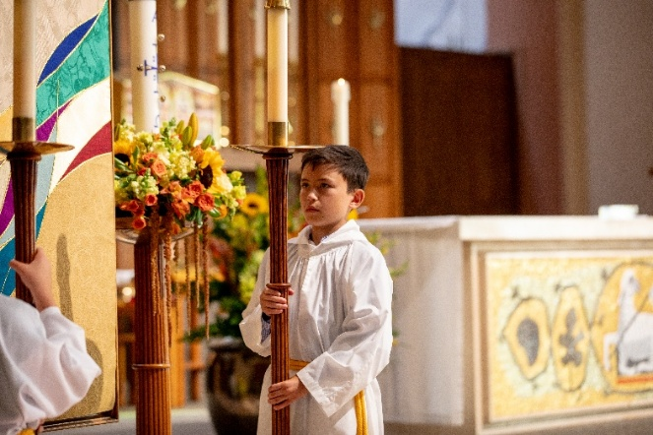
  - Raise the candles as high as you can hold them on either side of the ambo, without blocking the priest or deacon as the Gospel is being read. If your arms get tired, just lower the candle. Just make sure the candles are the same height once you raise them.
Note: If there is incense, the order of the processions is: candle, thurifer (incense), priest, candle. After all turn to face the congregation and the candle leads the way, the thurifer will lead the priest to the stairs of the ambo, and candles proceed as usual.
- The priest or deacon proclaims the Gospel and finishes by saying, “The Gospel of the Lord.” And the congregation responds, “Praise to you Lord Jesus Christ!” As soon as this is completed, the two candle bearers proceed to the book stand near the high pulpit and stand on either side of it. The priest or deacon will come down from the pulpit, kiss the book of Gospels, place it on the book stand and then bow. The candles then turn toward the back wall and proceed behind the reredos and place the candles in the stands from which they removed them. They then sit in their chairs to listen to the homily.
- All other servers remain standing at their chairs for the Gospel, and for the enthroning of the Gospel and do not sit for the Homily until the priest or deacon has bowed when placing the Book of Gospels in the stand. Then we sit for the Homily.
- The priest/deacon will then preach his Homily.
- After the Homily, the priest/deacon will go back to their seat (some will sit, and some will stand and go right into the creed). If he sat after his homily, the priest will stand for the Profession of Faith/Creed (unless omitted). As soon as celebrant stands or right away if he doesn’t sit, the book bearer approaches the priest to hold the binder, which will be on the celebrant’s table with the Excerpts from the Roman Missal. The other servers stay standing at their chairs.
- At the end of the Prayers of the Faithful, the priest concludes with a prayer and an announcement about our weekly gift. As the announcement for weekly gift is made, the cross and candle bearers grab the cross and the two lit candles from their stands (the candles on the either side of the altar are never moved or touched during mass) and proceed down the side aisle near the musicians/choir to the front of the baptismal font to prepare to lead the procession of the gifts. The order is: cross and two candles next to crosse, followed by two gift bearers side by side. The book bearer places the binder on the celebrant’s table and proceeds to prepare the altar. Please note: The above is for when there are 4 servers. If there are three servers: then after the announcement about the weekly the book/cross bearer, the book places the binder on the table and then grabs the cross along with the two candle bearers with the two candles and go back to lead the offertory procession of the gifts and the priest prepares the altar. If there are two servers, after the announcement, the server holding binder places the binder on the table then two candles go back and lead the offertory procession and the priest prepares the altar, unless the priest prefers only the cross to lead the gifts and the other server to prepare the altar. If there is one server, then after the announcement, place the binder on the table, and then grab the cross and go to the back to lead the offertory processing with just the cross. Priest prepares the altar.
- The congregation sits down.
- When there are 4 servers, the book bearer prepares the altar as below.

LITURGY OF THE EUCHARIST

OFFERTORY COLLECTION/PROCESSION
- As everyone is sitting, the cross and two candle bearers with the cross and/or lit candles from the stands proceed from their chairs and get the cross and two lit candles to the back of the church and stand in front of the baptismal font. Proceed with the offertory procession as soon as the priest and server approach the center of the sanctuary. Check with Priest for offertory procession if only two servers.

PREPARATION OF THE ALTAR
- Sanitize your hands.
- Remove the plastic book stand that held the Book of Gospels (go around to the front of the altar if you cannot reach it from behind the altar) and place it on the shelf under the credence table behind the altar near the tabernacle.
- Grab the chalice/patent set up by placing your dominant hand on the stem of the chalice and placing your other hand on top of the corporal. Set it on the altar. Remove the chalice pall and place it to the right. Then take the corporal and set it in the center of the altar so that when the book is placed the book is not on the corporal. The corporals open in thirds, and the cross is always at the bottom. Then place the patent with the large host to the right on the bottom right side of the corporal, with the empty chalice and purificator right next to it. The Roman Missal is placed open at the first green tab, page 381 and placed near the edge of the bottom of the altar and centered, with the top of the book on the corproal.
- If there is an empty ciborium on the credence table/tray leave it and then bring it to the priest at the Lamb of God. If there is an extra ciborium with hosts in it, then place it on the upper left-hand corner of the corporal with the lid remaining on.
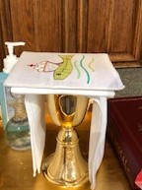
- If there is a pyx on the table, place the closed pyx on the center corporal and open the pyx.
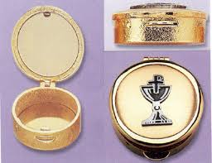

- Below is what a prepared altar looks like:
Corporal spread out center of altar with cross at bottom.
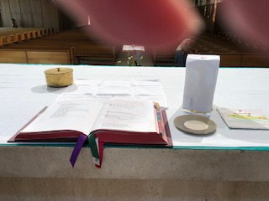
Extra ciborium if contains hosts—you need to place when you prepare the altar; otherwise, if it is empty leave and hand to priest at Lamb or God. If no extra on credence table, then nothing to do.
Chalice pall
Chalice covered with purificator or next to chalice.
Paten with celebrant’s host
Roman Missal opened to p. 381

- When finished with preparing the altar and then go to the celebrant’s chair and go with the priest to receive the gifts per below. If the priest is already standing at the center of the sanctuary to receive the gifts, then join him on his right side (please don’t cross in front of the priest).
- The priest will then get up and go to the center of the sanctuary to receive the gifts.
- The server who prepared the altar will go up and stand on the right side of the priest.
- When the priest rises to receive the gifts, the cross and candle bearers (or just candles or just cross) will then lead the gifts, holding the cross/candles high just like with the entrance. Walk at a normal pace forward, all going to the right of the lectern and proceeding to the center in front of the priest and server bow their head when they get in front of the priest and then proceed to put the cross and candles in their usual stands.
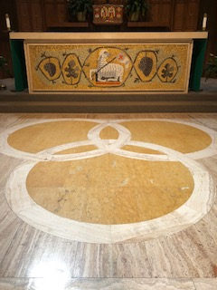
- They will then go to the altar servers’ table where one server will get the water pitcher and the other server the handwashing bowl and towel, placing the towel over your left forearm.
- The priest will accept the gifts, the wine cruet first, and then the ciborium (sometimes he takes them together) and hands the wine cruet to the server. All bow to gift bearers before proceeding to the altar with the gifts.

PREPARATION OF THE GIFTS
- The priest and the server turn to left toward the musicians/cantor and proceed to the altar with the gifts, the server following behind the priest. The server should remove the top of the wine cruet and place it on the tray on the credence table and also remove the top of the water cruet and grab the wine cruet in their right hand and the water in their left hand with the handles facing OUT so the priest can grab the each by the handle. Proceed to the priest’s right side and as soon as he puts the host down be prepared to hand him the wine cruet and while he pours the wine, transfer the water cruet from your left hand to your right. Receive the wine cruet in back from the priest with your left hand and hand the water cruet to priest handle facing him with your right hand. Stay in place, and after he places the water in the wine receive the water cruet in your right hand and then place both cruets on the tray and recap as he prays over the gifts.
- The candle bearers with the water pitcher and hand washing bowl/towel should approach the altar and stand just to the right of the priest as soon as the other server moves from his right side to credence table and while the priest is praying over the gifts and bows.
- As soon as he finishes bowing, approach for the hand washing.
  - The server with bowl and towel on his/her left arm holds the bowl under the priest’s hands, and the server with the water cruet pours the water on the celebrant’s hands. Some want less water than others. Fr, Gil will always want the entire amount of water in the small pitcher poured.
  - The priest will dry his hands with the towel and place it back on your arm. These two servers place the bowl, towel, and water cruet on the servers’ table and then join the other two servers standing at the bottom of the steps on the left side of the altar.
- If there is incense at the Mass, everything is the same except for the timing of the handwashing.
  - After the celebrant prayers over the gifts and BEFORE the handwashing, the thurifer approaches with incense. Once the celebrant has incensed the altar and the thurifer or deacon incenses the celebrant and proceeds to incense the congregation, then the two servers approach with bowl, towel, and water for handwashing, which occurs as the congregation is being incensed.
PLEASE NOTE: If there is a deacon at Mass, he will lead the preparation of the altar, receiving of the gifts, and preparation of the gifts, so the server(s) should assist him and follow his lead.

EUCHARISTIC PRAYER
- The priest then begins with the preface and then will enter the congregation into the Sanctus (HOLY HOLY), which will be sung or recited. The server ringing the bells gets the bells while the Sanctus is being sung, careful not to ring the bells.
- The bells are rung as roll, or a long continuous ring. Each roll has rings that sound like, da-da-da-da. Please listen to this recording very carefully on how to ring the bells at all three places in the Eucharist Prayer.
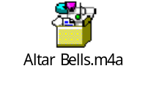
- The bells are rung the first time during the epiclesis (or the invocation of the spirit), when priest brings his hands down and holds them over the bread and wine, just before the consecration, and invokes the spirit. You will use the visual cue of when the priest brings his hands over the bread and wine to start ringing the bells with ONE Roll (not a single ring, but a single roll). He will invoke the spirit while the bells are ringing. Be sure to stop ringing before the consecration (when he makes a cross over the bread and wine). Don’t rush the ringing of the bells. Here is a photo of your visual cue to start ringing at the epiclesis:
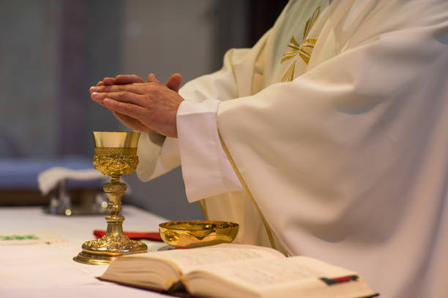
- The priest will first pick up the host, to be consecrated, by saying “Take this, all of you, and eat of it, for this is my Body, which will be given up for you.” The priest will raise (elevate) the Body of Christ to show the congregation. You wait until the host is fully elevated and being shown to the congregation to begin ringing the bells with three rolls, ensuring there is a pause between each roll. Do not start ringing when he finishes the words or when he starts to elevate the host. Wait until it is fully elevated and being shown to the congregation. Don’t rush the ringing of the bells. Ring first roll. Pause. Second roll. Pause, Third roll. Remember each roll is a long ringing that sounds like da-da-da-da. The priest will place the host back on the patent and then kneel or genuflect. All servers bow deeply in unison with the priest and each other, the server with the bells taking care not to let the bells ring while bowing. Here is your visual cue of when to start ringing:
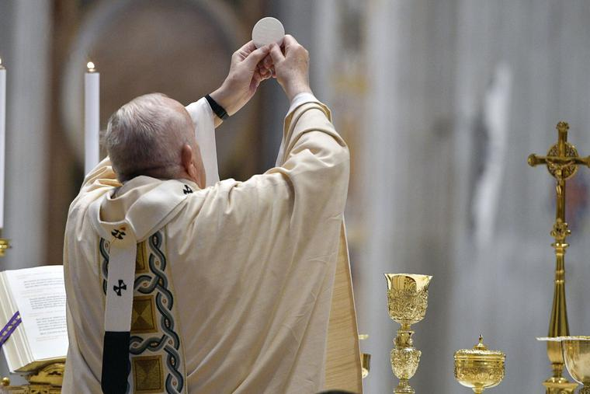
- The priest will then pick up the chalice and say, “Take this, all of you, and drink from it, for this is the chalice of my Blood, the Blood of the new and eternal covenant, which will be poured out for you and for many for the forgiveness of sins. Do this in memory of me.” He will raise the chalice, and just like with the host, when it is fully elevated and being shown to the congregation, slowly ring the bells with three distinct rolls. Here is your visual cue to ring the bells with the chalice elevation.
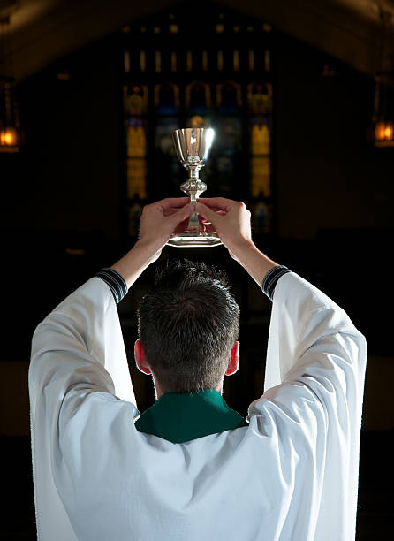
- We all bow deeply in unison with the priest and each other, again careful not to ring the bells. The server then returns the bells to their spot on the altar.
Please listen to the audio recording above.
- The priest will then proclaim the mystery of faith, and the memorial acclamation will be sung or recited. At this time the server with the altar bells puts them back.
- The priest will then finish the prayer by remembering the saints, all those who have departed before us, and chant or recite, “Through Him, with Him, and in Him….”
- The Great Amen will be sung or recited.
- All recite The Lord’s Prayer (Our Father) at the invitation of the celebrant.
- At the sign of peace, the servers give each other “peace” and the priest(s).
- Then wash your hands with gel (behind the altar)
- Proceed on to the altar at the Lamb of God.

COMMUNION
- The Lamb of God will either be sung by the choir or recited by the priest, and the congregation will join in
- The Eucharistic Minister(s) (EM) will clean their hands and step up to the altar.
- The priest will distribute the Body of Christ to all on the altar in the hand.
- Once the altar servers receive the Eucharist and the EMs have left the altar:
    - one server (candle) removes the Missal from the altar and places it back on the credence table.
    - Another server (candle) removes all ciborium lids except for 1 and places them on the credence table.
    - If there is a pyx on the altar, please leave it on the center corporal.
- Two servers (book and cross) then go to their chairs and remain standing in front of their chairs.
- The two candle bearer servers stand at the bottom of the side steps to the altar, near the reredos—one on each side of the altar.
- As the cross bearer goes to the stand in front of their chair, they grab the binder for announcements. Book bearer leaves the red Excerpts from the Roman Missal on the celebrant’s table and stands in front of their chair.
- DURING COMMUNION, PLEASE DO NOT GO INTO THE PRIEST OR LITUGICAL MINISTERS SACRISTIES UNLESS YOU ARE ILL OR NEED TO USE THE RESTROOM OR GET A TISSUE.
- Servers should always remain in the sanctuary unless they perform duties or they have been asked by another minister to retrieve something.
- Once the priest is done distributing communion, he will return to the altar, and all the Eucharistic Ministers will come to him with their ciboria.
  - The two candle servers who have been standing follow the priest and EMs up the stairs to the altar.
  - The priest will consolidate all remaining hosts from the ciboria into one.
  - One server needs to be standing by to take the empty ciboria(um) from the priest and place it/them on the credence table.
  - The priest will then place the lid on the altar on the ciborium with the consecrated hosts and then turn to place it in the tabernacle. When he approaches the tabernacle, the two servers on the altar turn and face the tabernacle until the celebrant has secured the ciborium in the tabernacle and locked it, at which time he will bow or genuflect, and the two servers join him in bowing or genuflecting and then turn around. One server returns to his/her chair and the other remains on the altar. The remaining server needs to remove the cap from the water cruet and be ready.
  - The priest will then purify the chalice, where he will immediately need the water from the credence table. He may want you to hand it to him or he may want you to pour a small amount in chalice. Once the water is in the chalice, the server should return the water cruet to the credence and cap it. Meanwhile, the priest will swirl the water in the chalice and consume it, then clean it with the purificator.
  - He will then place the purificator over the chalice then the paten on the purificator. He will carefully fold the corporal and place it on the paten, then place the chalice pall and either hand it to the server, where you take it with hand on the stem of the chalice and one on top of the chalice pall. He might leave it on the altar and step aside for the server to then take the set up by the stem of the chalice in one hand and the other hand on top of the chalice pall. Either way, once the server has it, he/she places it on the tray on the credence table. Both the server and celebrant face the tabernacle and bow while sanitizing their hands. NOTE: Sometimes, after purifying the chalice, the priest will go to his chair. If so, then the remaining server folds the corporal back into square and places the purificator over the chalice, then the paten, then the corporal on top of the paten, and then the chalice all and returns it to the credence table. This is the reverse of the set up.
  - The priest returns to the celebrant’s chair, and the server returns to his/her chair against the wall next to the other server and all then sit when the priest sits in his chair.
  - As soon as you all sit, book bearer picks up the Excerpts from the Roman Missal and opens to the page for the Prayer after Communion, remaining seated until the priest stands.
  - At the same time, while seated, the cross bearer opens the binder to the announcements.
  - When the priest stands, all stand at the same time; the priest will say, “Let us pray,” the book bearer approaches the celebrant with red book, Excepts from the Roman Missal, open to Prayer after Communion for that Sunday (it is the same page as the opening prayer and marked by a ribbon).
  - At the end of the Prayer after Communion, book bearer steps back in front of their chair and the other server with the binder steps in front to hold the binder for the announcements. Book bearer closes the Excerpts from the Roman Missal and places it on the celebrant’s table, unless the priest plans to offer a solemn blessing at the end of mass after the announcements. Please confirm this before Mass and make sure the blessing page is marked with a ribbon. If so, then step aside in front of your chair and then open the book to the blessing page and stand by until announcements are concluded.

CONCLUDING RITES
- As soon as the book bearer moves aside with the Missal, the cross bearer steps in with the binder open to the announcements. Some priests will want you to hold the binder for the announcements; some will not and will grab the binder from you and then place it on the table when finished. If you are holding the binder for announcements, when concluded step back in front of your chair and close the binder, ready for the final blessing and dismissal.
- Usually, the celebrant will offer the final blessing and dismissal without the book or binder.
- If there is a special blessing, it may be in the book or binder, and the priest will let you know to stand aside while announcements are read.
- Pay close attention for cues (such as “Let us pray…” “Bow your head and pray for Gd’s blessing…” a look over toward you) from the celebrant and always check in with the celebrant before Mass.
- If there is no special blessing, the priest will then conclude the Mass with the Sign of the Cross (no need to hold the book).
- The deacon or priest will offer the dismissal, which the congregation responds with, “Thanks Be to God!”
- Servers place binder and Missal back on celebrant’s table (please go behind the priest and chairs).

RECCESION
- As soon as we say, “Thanks be to God,” the cross bearer and candle bearers grab the cross and candles from their stands and proceed to base of the steps in front of the lectern, with the book following behind.
- The cross lines up at the first pew facing the altar and raises the cross very high (as high as you can comfortably hold it)—and turns to face the altar with their back to congregation.
- The candles line up, right next to (or just in front) to cross facing the altar— and turns to face the altar with their back to congregation.
- The book bearer (carrying nothing) lines up in front of the candles facing the altar—back to the congregation.
- The priest will then go to the altar and reverences it and then and come to some place in front of the altar and faces the altar, back to congregation. Some will come to step just above where the servers are; others will stand at the top of the steps.
- All servers pay close attention to the celebrant. The priest will bow and turn. The book bearer will bow at the same time as the priest and all (cross, candles, book bearer) turn around when the priest turns around and the cross leads the recession out. Candles and cross go as unit until the baptismal font and then slot there.
- If there are more than 4 servers, then all is the same except all those not carrying the cross or candles, line up in a straight line along the bottom step and all bow when celebrant bows. The cross leads us out followed by candles, and the servers from each end of the line go two together, followed by the next two from each side, followed lastly by the server(s) in the middle. In other words, you recess out from the outside of the line in with the person in the center of line going last.

AFTER MASS
- After the sending song is finished, servers then return the cross and candles to their stands on the altar. Book bearer grabs the candle snuffer from the Incense Cupboard (see pics below) in the sacristy hallway and uses the snuffer to extinguish all candles. FOR SAFETY, PLEASE DO NOT BLOW OUT THE CANDLES—USE ONLY THE SNUFFER.
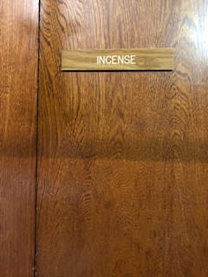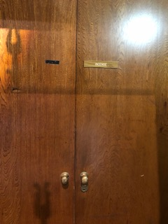
- Two servers take the used hand washing bowl, pitcher, and towel from the altar servers table and all servers return to the Liturgical Ministers’ (working) sacristy.
- All servers remove their cinctures and hang them up in the closet, then remove their albs and place them in the gray laundry hamper—please do not hang them up after wearing them.
- Servers help clean up. Please place the used hand washing towel in the hamper in the priests’ sacristy.
- Wash and dry the hand washing bowl and pitcher and place back in the vessels’ cupboard.
- Before leaving, please check in with the altar server coordinator or committee member (if present) or celebrant for a quick debrief and to see if any additional help is needed.

Reminders

- When you are standing or sitting, and not doing anything, keep your hands folded in your lap or in the praying position. Do not play with, fiddle with, or swing your cincture.
- PLEASE PAY ATTENTION, especially to the priest.
- PLEASE DO NOT talk or argue when you are on the altar. If you are not sure or need help during mass ask a senior server, or the celebrant.
- Please review the Liturgy Guide (at the end of this document or on Altar Server Bulletin Board near the sign-in sheet) for more information on basic liturgy and for a glossary of terms with photos for reference.
- If you need to use the restroom, or get a tissue, or drink a drink of water in hot weather, use the facility in the liturgical minister sacristy.
- If you are signed up to serve, please follow the Dress Code. Walk-on servers will not be held accountable to dress code.
- For a quick refresher, please refer to the Altar Server Quick Reference Guide from your training.
- Please review the Liturgy Guide and Names of Places and Things (with pictures) in the Appendix.

PLEASE NOTE: EXCEPT AS NOTED THESE PROCEDURES ARE FOR 4 OR MORE SERVERS. IF THERE 3, 2, OR 1 ADJUSTMENTS THROUGHOUT NEED TO BE MADE AND SERVERS WILL SERVE IN MULTIPLE ROLES. FOR EXAMPLE, IF YOU ARE ALONE PLACE THE HANDWASHING BOWL, TOWEL AND WATER PITCHER UNDERNEATH THE CREDENCE TABLE. IF THERE TWO OR MORE IT GOES ON THE ALTAR SERVER TABLE BEHIND THE REREDOS.

THE RECESSION IS ALWAYS THE SAME AS THE PROCESSION.

WHEN THERE ARE MULTIPLE CONCELEBRANTS THEN ALL SERVERS SIT IN THE SERVER CHAIRS AGAINST THE WALL AND THE CELEBRANTS TABLE IS MOVED OVER THERE WITH THE BOOK AND BINDER. THE BOOK BEARER WILL THEN ALWAYS GRAB THE BOOK FROM THE TABLE AND APPROACH FROM BEHIND AND STAND IN FRONT OF THE CELEBRANT.

THANK YOU for your service. Learn and have fun! The more you serve, the more comfortable and confident you will be, the more you will learn and the more fun you will have in your ministry.

Appendix 1. Basic Liturgy Knowledge for Altar Servers
The liturgical year is made up of six seasons:
- Advent - four weeks of preparation before the celebration of Jesus' birth. Color: Purple
- Christmas - recalling the Nativity of Jesus Christ and his manifestation to the peoples of the world. The Christmas season lasts 4 weeks starting with Christmas Eve. Color: Gold or White. We typically wear Gold at SPA.
- Lent - a six-week period of penance before Easter. Color: Purple
- Sacred Paschal Triduum - the holiest "Three Days" of the Church's year, where the Christian people recall the suffering, death, and resurrection of Jesus. Colors: Holy Thursday- White; Good Friday: Red; Vigil: Gold
- Easter – Starting with Easter Sunday, the Easter season is 50 days of joyful celebration of the Lord's resurrection from the dead and his sending forth of the Holy Spirit. Color: Gold
- Ordinary Time - divided into two sections (one span of 4-8 weeks after Christmas Time and until Lent and another lasting about six months after Easter Time), wherein the faithful consider the fullness of Jesus' teachings and works among his people. Color: Green
- Other Considerations- Holy days and Feast Days the color is usually White (except as noted below). Funerals, Weddings, and Baptisms the color is White. Masses of the Holy Spirit, Palm Sunday, Good Friday, Pentecost, and Confirmations the color is Red (the exception to this is when the Confirmation ceremony/Mass occurs during the Easter season, at which time the color of the Easter Season takes precedence, and we wear Gold.

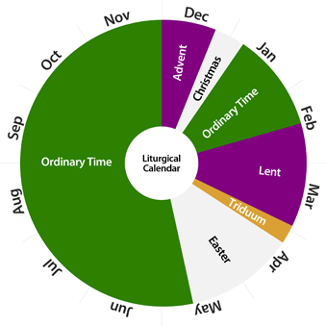
The Liturgical Colors are as follows:
Green‐ Used during Ordinary Time symbolizing life, growth, and hope.
Violet/Purple‐ Used during the seasons of Lent and Advent. It may also substitute for white on All Souls’ Day and in Masses for the Dead. It symbolizes penance.
White ‐ May be used during the Christmas season; it is used at feasts of saints who are not martyrs, Holy Thursday, on feasts of Our Lord and Our Lady. It symbolizes holiness, joy, innocence, and triumph.
Red‐ Used during Pentecost, Palm Sunday, Good Friday, on feasts of martyrs, and on feasts of
apostles and evangelists. It symbolizes the blood shed by the Martyrs and Our Lord. It also
represents the tongues of fire which descended on the Apostles at Pentecost. It may also be used for Confirmation when the ceremony is not during the Easter Season.
Black‐ Used as an alternative to white or violet on All Souls’ Day and in Masses for the Dead. It
symbolizes mourning. Please note we do not have black cinctures, so we then wear white or violet.
Gold ‐ Used at Christmas, the Christmas season, Holy Easter Vigil, Easter Sunday, the Easter season, and special solemnities as an alternative to white or green.

Order Of Mass

Introductory Rites
- Entrance
- Greeting
- Penitential Act
- Glory to God
- Collect

The Mass begins with the entrance chant/song. The celebrant and other ministers enter in procession and reverence the altar with a bow and/or a kiss, unless carrying the cross or candles. The altar is a symbol of Christ at the heart of the assembly and so deserves this special reverence.
All make the Sign of the Cross, and the celebrant extends a greeting to the gathered people in words taken from Scripture.
The Penitential Act follows the greeting. At the very beginning of the Mass, the faithful recall their sins and place their trust in God's abiding mercy. The Penitential Act includes the Kyrie Eleison, a Greek phrase meaning, "Lord, have mercy." This litany recalls God's merciful actions throughout history. On Sundays, especially in Easter Time, in place of the customary Penitential Act, from time to time the blessing and sprinkling of water to recall Baptism may take place.
On Sundays, solemnities, and feasts, the Gloria follows the Penitential Act. The Gloria begins by echoing the proclamation of the angels at the birth of Christ: "Glory to God in the highest!" In this ancient hymn, the gathered assembly joins the heavenly choirs in offering praise and adoration to the Father and Jesus through the Holy Spirit.
The Introductory Rites conclude with an opening prayer, called the Collect. The celebrant invites the gathered assembly to pray and, after a brief silence, proclaims the prayer of the day. The Collect gathers the prayers of all into one and disposes all to hear the Word of God in the context of the celebration.

Liturgy of the Word
- First Reading
- Responsorial Psalm
- Second Reading (on Sundays and solemnities)
- Gospel Acclamation
- Gospel
- Homily
- Profession of Faith (on Sundays, solemnities, and special occasions)
- Universal Prayer
Most of the Liturgy of the Word is made up of readings from Scripture. On Sundays and solemnities, there are three Scripture readings. During most of the year, the first reading is from the Hebrew Scripture (AKA Old Testament), and the second reading is from one of the New Testament letters. During Easter Time, the first reading is taken from the Acts of the Apostles which tells the story of the Church in its earliest days. The last reading is always taken from one of the four Gospels (Matthew, Mark, Luke, John).
In the Liturgy of the Word, the Church feeds the people of God from the table of his Word. The Scriptures are the word of God, written under the inspiration of the Holy Spirit. In the Scriptures, God speaks to us, leading us along the path to salvation.
The Responsorial Psalm is sung between the readings. The psalm helps us to meditate on the word of God.
The high point of the Liturgy of the Word is the reading of the Gospel. Because the Gospels tell of the life, ministry, and preaching of Christ, it receives several special signs of honor and reverence. The gathered assembly stands to hear the Gospel, and it is introduced by an acclamation of praise and procession of candles (if there are enough servers) and sometimes incense. Apart from Lent and Advent, that acclamation is "Alleluia," derived from a Hebrew phrase meaning "Praise the Lord!" A deacon (or, if no deacon is present, a priest) reads the Gospel, with candles held in honor.
After the Scripture readings, the celebrant preaches the homily. In the homily, the preacher focuses on the Scripture texts or some other texts from the liturgy, drawing from them lessons that may help us to live better lives, more faithful to God’s call to grow in holiness.
In many Masses, the Profession of Faith then follows the homily, either the Nicene Creed or Apostles' Creed. The Nicene Creed is a statement of faith dating from the fourth century, while the Apostles' Creed is the ancient baptismal creed of the Church in Rome. If baptismal promises are renewed, from a formula based on the Apostles' Creed, this takes the place of the Creed. This most often happens during the Easter Season.
The Liturgy of the Word concludes with the Universal Prayer, also called the Prayers of the Faithful. The gathered assembly intercedes with God on behalf of the Church, the world, and themselves, entrusting their needs to the faithful and loving God. The series of intentions is usually to be:
a) for the needs of the Church.
b) for public authorities and the salvation of the entire world.
c) for those burdened by any kind of difficulty.
d) for the local community.
Nevertheless, in any particular or special celebration, such as a Grade Mass, a School Mass, Confirmation, a Marriage, or at a Funeral, the series of intentions may be concerned more closely with the specific occasion.
The celebrant begins it with a brief introduction, by which he calls upon the faithful to pray, and likewise he concludes it with a prayer. They are announced from the ambo or lectern by the Deacon, or a lay lector (reader). The congregation stand and give expression to their prayer either by an invocation said in common after each intention or by praying in silence. The presiding priest concludes it with a prayer.

Liturgy of the Eucharist
- Preparation of the Altar, Presentation of the Gifts, and Preparation of the Gifts
- Prayer over the Offerings
- Eucharistic Prayer
  - Preface
  - Holy, Holy, Holy
  - First half of prayer, including the Epiclesis and Consecration
  - Mystery of Faith
  - Second half of prayer, ending with Doxology
- The Lord's Prayer
- Sign of Peace
- Lamb of God
- Communion
- Prayer after Communion

The Liturgy of the Eucharist begins with the preparation of the gifts and the altar. As the servers and ministers prepare the altar, representatives of the people bring forward the bread and wine, led by the cross and two candles (or cross only or two candles only) that will become the Body and Blood of Christ. The celebrant blesses and praises God for these gifts and places them on the altar. In addition to the bread and wine, monetary gifts for the support of the Church and the care of the poor may be brought forward. The Prayer over the Offerings concludes this preparation and readies all for the Eucharistic Prayer.
Eucharistic Prayer
The Eucharistic Prayer is the heart of the Liturgy of the Eucharist. In this prayer, the celebrant gathers not only the bread and the wine, but the substance of our lives and joins them to Christ's perfect sacrifice, offering them to the Father. It includes elements of Thanksgiving, invocation of the Holy Spirit, Consecration, the memorial acclamation, and the concluding doxology, by which the glorification of God is expressed, and which is enthusiastically affirmed and concluded by the people's acclamation "Amen."
The Eucharistic Prayers make clear that these prayers are offered to God, the Father. It is worship offered to the Father by Jesus as it was at the moment of His passion, death, and resurrection, but now it is offered through the priest, and by all the baptized, who are the Church and the Body of Christ.

Communion Rite
The Communion Rite follows the Eucharistic Prayer, leading the faithful to the Eucharistic table.
The rite begins with the Lord's Prayer. Jesus taught this prayer to his disciples when they asked how to pray. In this prayer, the people join their voices to pray for the coming of God's kingdom and to ask God to provide for our needs, forgive our sins, and bring us to the joy of heaven.
The Rite of Peace follows. The celebrant prays that the peace of Christ will fill our hearts, our families, our Church, our communities, and our world. As a sign of hope, the people extend to those around them a sign of peace.
In the Fraction Rite, the celebrant breaks the consecrated bread as the people sing the Agnus Dei or "Lamb of God." The action of breaking the bread recalls the actions of Jesus at the Last Supper, when he broke the bread before giving it to his disciples. One of the earliest names for the Eucharistic celebration is the breaking of the bread.
Before receiving Holy Communion, the celebrant and assembly acknowledge their unworthiness to receive so great a gift. The celebrant receives Holy Communion first and then the people come forward.
As the people receive Holy Communion, the communion chant/song is sung. The unity of voices echoes the unity the Eucharist brings. All may spend some time in silent prayer of thanksgiving as well.
The Communion Rite ends with the Prayer after Communion which asks that the benefits of the Eucharist will remain active in our daily lives.

Concluding Rites
- Optional announcements
- Greeting and Blessing
- Dismissal
During the Concluding Rites, announcements may be made (if necessary) after the Prayer after Communion. The celebrant then blesses the people assembled. Sometimes, the blessing is quite simple. On special days, the blessing may be more extensive. In every case, the blessing is always ends with: "May almighty God bless you, the Father, and the Son, and the Holy Spirit," as it is in the sign of the cross that we find our blessing.
After the blessing, the deacon (or priest if no deacon) dismisses the people. Fun fact: the dismissal gives the liturgy its name. The word "Mass" comes from the Latin word, " Missa." At one time, the people were dismissed with the words "Ite, missa est" (meaning "Go, she—you, the Church—has been sent"). The word "Missa" is related to the word "missio," the root of the English word "mission." The liturgy does not simply end. Those assembled are sent forth to bring the fruits of the Eucharist to the world.
The Liturgy ends with the Final Song or Hymn and Recession.

Appendix 2. Names of Places and Things

This is a handy reference guide for all the places and things involved in our worship. Some of these terms are quite common things all servers should know. Some terms are a little less common and terms only a senior or experienced server will need to know or items that any server might only encounter during a special Mass, like Confirmation, funerals, weddings, or liturgies at Triduum (the triad of liturgies before Easter—Holy Thursday, Good Friday, and Easter Vigil). Finally, there are some uncommon terms that you may never encounter, but just in case someone ever says it or asks for it, you can learn about it here. Enjoy learning more about the places and things we use in our liturgies.
COMMON LITURGICAL ARTICLES AND PLACES
Terms all servers should be familiar with and have a working knowledge of.

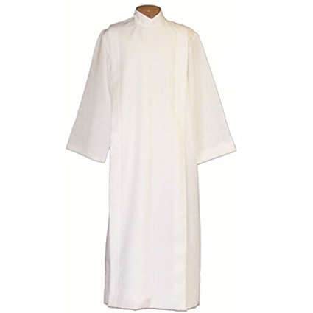 | Alb- One of the liturgical vestments, worn by clergy and servers. It is a white garment coming down to the ankles and is usually girdled with a cincture. They are white as a reminder of baptism.
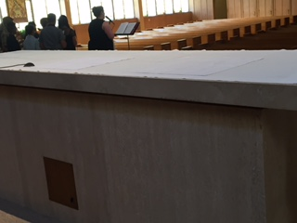 | Altar‐ The table on which bread and wine are transformed into the Body and Blood of Jesus.
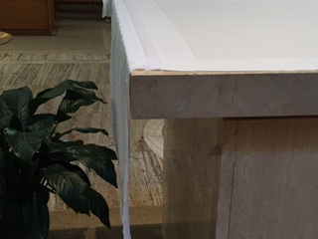 | Altar/Tablecloth- An altar cloth is used by various religious groups to cover an altar. It may be used as a sign of respect towards the holiness of the altar.
 | Altar Server/Concelebrant/Deacon Chair-The two smaller chairs on either side of the celebrant. If there is no deacon or concelebrant then two servers sit there, typically book and cross. The bear bearer sits to the right of celebrant with the celebrant’s table between them.
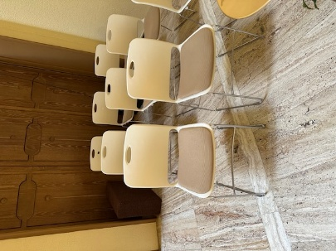 | Altar Server Chairs- The two candle servers(and other serves) sit behind the celebrant/deacon chairs or where all sit when there are concelebrants who sit in the chairs on either side of the celebrant. In that case move the celebrant’s table with book and binder next to these chairs and approach with the book or binder from here
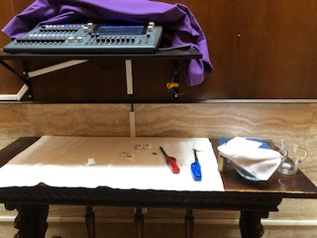 | Altar Server Table-The table behind the reredos to the where the handwashing bowl, water cruet, towel, lighters, incense, and other supplies for the servers are placed during the Mass
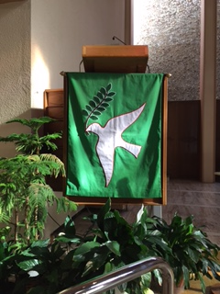 | Ambo ‐ The place from which the Scriptures are proclaimed and sometimes the homily is given.
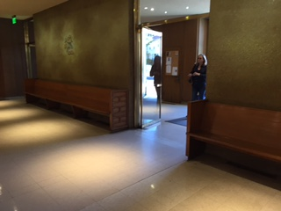 | Back of the Church/Front Entrance of Church-The area where the procession gathers prior to the procession. It is also the area where the gifts are kept and where the offertory process with candles and gifts begins.
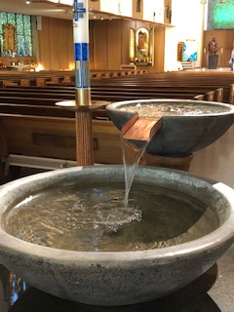 | Baptismal Font-Located just inside the entrance of the church. It is where all baptisms occur and is the source of holy water.
 | Boat/Incense Boat‐ A small receptacle made of precious metal that holds incense to be used in the thurible.
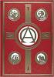 | Book of Gospels‐ A book with an ornate cover containing only the four Gospels. It is carried in the entrance procession by the deacon or lector and placed upon the altar until the Gospel Acclamation.
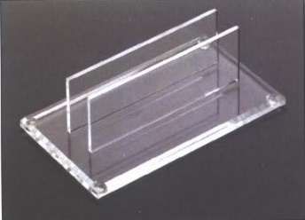 | Book of Gospels Stand-A transparent plastic, wood, or metal stand that holds the Book of Gospels in the center of the altar (ours is plastic). When the Book is processed in the Lector or Deacon places it in the stand. If the Book is not processed in, then the Book of Gospels is placed in the stand in the center, front of the altar prior to Mass by either the sacristan, altar server, or lector. During the Alleluia, the Deacon or Celebrant removes it from this stand and processes it to the Ambo.
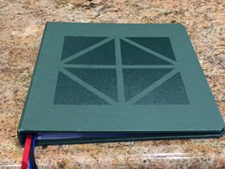 | Celebrant Binder-The binder that is used instead of the missal. It is the same color as the liturgical color of the Mass being celebrated
 | Celebrant Chair‐ The chair that the priest sits in during the celebration of the Mass.
 | Celebrant Table-The table to the right of the celebrant, which holds the Excerpts from the Roman Missal, binder, worship aid, etc.
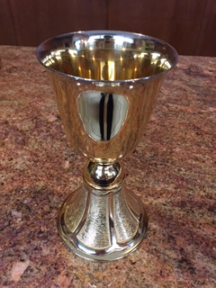 | Chalice – A vessel of gold that holds the wine which becomes the Blood of Jesus after the consecration.
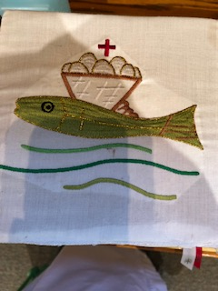 | Chalice Pall - A square piece of cardboard covered by white linen and used to cover the chalice. It is usually embroidered with a cross or some other appropriate symbol. It is used to prevent dust, insects, and other items from falling into the chalice
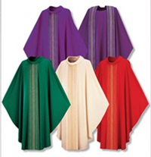 | Chasuble- The outermost liturgical vestment worn by priest for the celebration of the Eucharist. The chasuble is usually worn over the stole and alb. Like the stole, it is normally of the liturgical color of the Mass being celebrated.
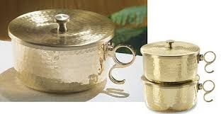  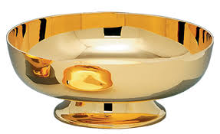 | Ciborium ‐ A large container of precious metal with a cover of the same material which will hold the Body of Christ after the consecration for distribution of Holy Eucharist. An open ciborium is used during Mass to hold the hosts to be consecrated and to distribute communion. A closed ciborium is used to store consecrated host in reserve in the tabernacle.
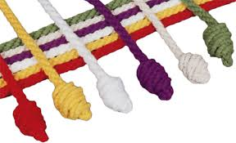 | Cincture- A long, rope-like cord with tasseled or knotted ends, tied around the waist outside the alb. The color may be white or may vary according to the color of the liturgical season. A Catholic bishop's cincture is made of intertwining gold and green threads, a cardinal's is red and gold, and the pope's is white and gold.
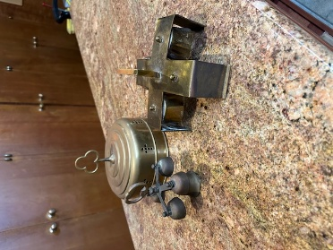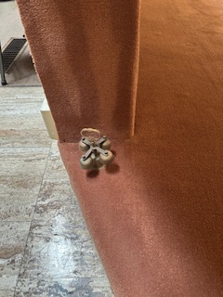 | Consecration Bells‐ Four small bells attached to a single handle used during the elevation of the Body and Blood of Christ. We use these at all masses, including school masses. We use all the bells during the Gloria at Triduum.
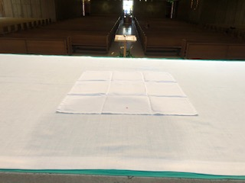 | Corporal ‐ A square, white linen cloth with a cross in the center used to protect any particles of the Host or drops of Precious Blood from being lost.
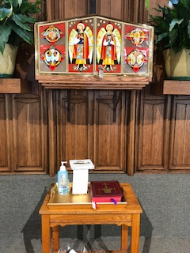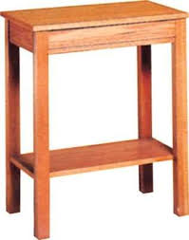 | Credence Table ‐ The table in the sanctuary that holds the cruets, chalices, and ciborium before and after the Consecration. At SPA, this is the table behind the altar under the tabernacle.
 | Cruets‐ Two small, matching glass pitchers used to hold the water and wine before consecration.
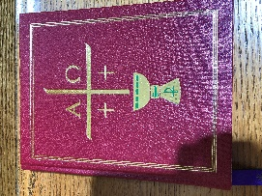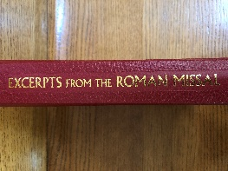 | Excerpts from Roman Missal-Contains the Order of the Mass and the opening prayers and prayers after communion for each Sunday. It is used at the beginning and end of Mass. It should always be on the Altar Servers’ bench before and during Mass.
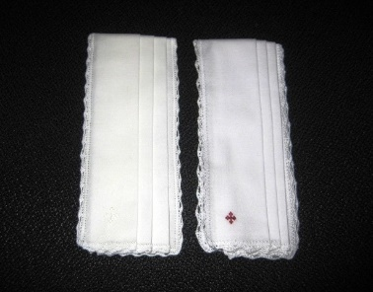 | Finger Towel (handwashing towel) ‐ A small towel used to dry the priest’s fingers/hands.
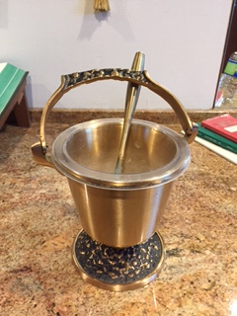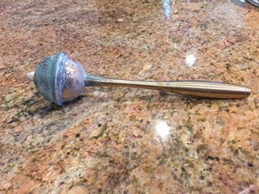  Sprinkler | Holy Water Bucket and Sprinkler (aspergillum/aspergil) – the holy water bucket holds the holy water so that the celebrant can dip the sprinkler in the bucket and sprinkle the people or objects to be blessed.
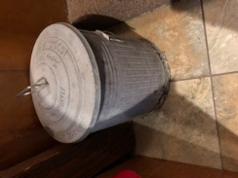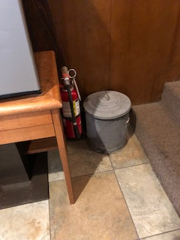 | Incense Ash Bucket-This is where the foil and cooled ashes from incense are disposed, including any paper towels used to clean/dry the thurible. It is in working sacristy to the right of the cupboard with vessels.
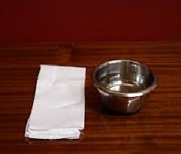 | Lavabo (handwashing bowl) ‐ A small bowl, along with the cruet of water and finger towel used to wash the priest’s fingers before the Consecration. These are most often used at daily Mass here at SPA; for Sunday Masses we use a larger bowl and larger towel. Most parishes, however, use the Lavabo and Finger towel for all Masses.
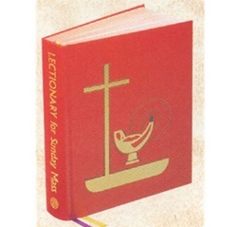 | Lectionary ‐ The book containing Scripture used for the Liturgy of the Word. It usually contains all the readings used for the three-year cycle of Sunday readings and the two-year cycle of daily Mass readings.
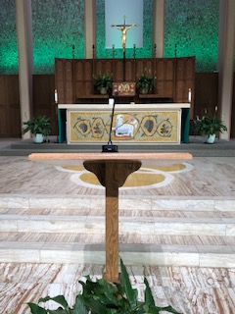 | Lectern-This is at the base of the steps to the sanctuary right in the center of the aisle. Always process to the right of the lectern.
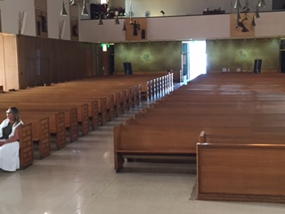 | Nave‐ The area of the church where the congregation sits—where the pews are.
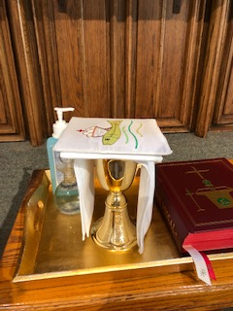 | Paten ‐ A small saucer shaped plate of precious metal that holds the Host and sists on top of the purificator covering the chalice and sits under the corporal and chalice pall.  Paten sits under here.
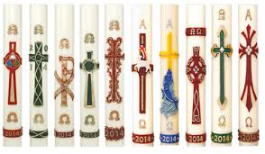  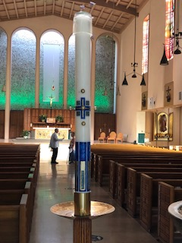 | Paschal Candle-The Paschal candle represents Christ, the Light of the World. The candle is made with pure beeswax, which represents the sinless Christ who was formed in the womb of His Mother. The wick signifies His humanity, the flame, His Divine Nature, both soul and body. Five grains of incense inserted into the candle in the form of a cross recall the aromatic spices with which His Sacred Body was prepared for the tomb, and of the five wounds in His hands, feet, and side. During the Easter Vigil on Holy Saturday night the priest or deacon carries the candle in procession into the dark church. A new fire, symbolizing our eternal life in Christ, is kindled which lights the candle. The candle, representing Christ himself, is blessed by the priest who then inscribes in it a cross, the first letters and last of the Greek alphabet, (Alpha and Omega `the beginning and the end') and the current year, as he chants a prayer; then affixes the five grains of incense. The Easter candle is lit each day during Mass throughout the Paschal season until Ascension Thursday. The Paschal candle is lit during Baptisms, Confirmations, and Funerals. It sits near the Baptismal Font outside the Easter Season (in the sanctuary near the Ambo during the easter Season), and is moved up to the center of sanctuary next to cremains or casket during funerals
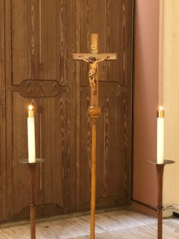 | Processional Candles‐ Small candlesticks carried by two altar servers in processions.
 | Processional Cross‐ Tall crucifix carried by an altar server in processions.
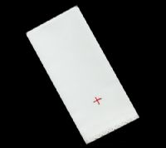 | Purificator ‐ A linen cloth used by the priest, deacon, or lay Eucharistic Minister to dry the chalice after purifying it.
 | Pyx ‐ A case, about the size of a pocket watch, in which Communion is carried to the sick or those unable to come to church. Check the celebrant preference card to know what to do with pyx when clearing the altar during communion.
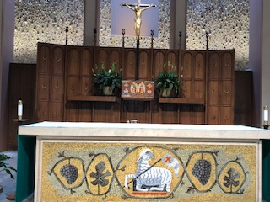 | Reredos- A large altarpiece, a screen, or decoration placed behind the altar in a church. It often includes religious images.
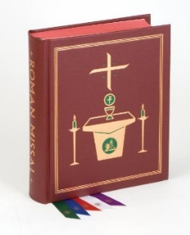 | Roman Missal ‐ The book containing the prayers said by the priest during the Mass.
 | Sacristan- The Person in charge of the sacristy and the liturgical vessels. Duties vary by community, but the basic jobs are these: Preparing the Holy Eucharist for the celebration of the mass. This includes getting the wine, water, and hots ready and putting them in place for the start of mass. Setting up the church. Typically, sacristans arrive at church before anyone else- often even the priest/celebrant. They light the candles, arrange the books, and perform a little housekeeping before mass begins; assisting the altar servers-sacristans prepare and help the altar servers perform their basics duties before and during mass. Cleaning the holy materials after Mass. This is done in the sacristy (see below), where the holy containers for the water, body, and blood are stored and cleaned. Everything is set back in its place in the sacristy before the sacristans leave the church. At the Sunday 5:00 PM Mass at SPA, the sacristan will often also set up for daily mass and close and lock the church before leaving.
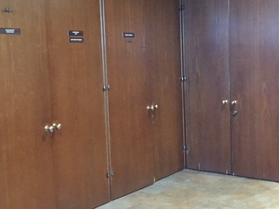Priest Sacristy  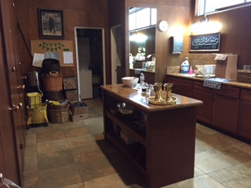  Liturgical Minister’s/Altar Server Sacristy  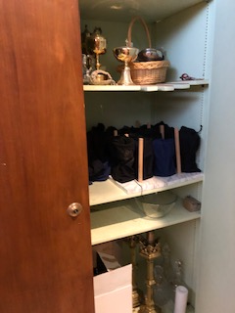  Cupboard in Liturgical Minister/Altar Server Sacristy where the handwashing bowl and vessels are. | Sacristy‐ The room behind the altar used to store the sacred vessels and other items used for Mass. At SPA, we have two: the priests’ sacristy, which is to the right as you come behind the altar and the Liturgical Ministers’ (and altar server) sacristy, which is where you sign in and vest when you are an altar server and get the handwashing bowl for set up. The priests’ sacristy is where lights for the church, portable lights, holy books, and microphones are.
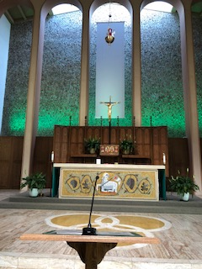 | Sanctuary‐ The part of the church in which the Liturgy of the Word and the Liturgy of the Eucharist take place.
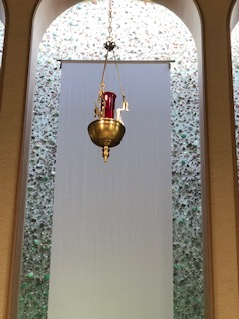 | Sanctuary Lamp‐ The red candle mounted in the center of the sanctuary that signifies the presence of Jesus in the Blessed Sacrament.
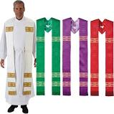 | Stole- A liturgical vestment composed of a strip of material from two to four inches wide and about eighty inches long. A small cross is sewn or embroidered on the stole at both ends and in the middle. The priest kisses the cross in the middle before putting it on. Deacons, priests, and bishops only wear the stole. Deacons wear the stole like a sash, the vestment resting on the left shoulder and thence passing across the breast and back to the right side. The stole of the priest extends from the back of the neck across the shoulders to the breast, where the two halves either cross each other or fall straight according as the stole is worn over the alb or the surplice. The color matches the Liturgical season in which the Mass is being celebrated.
 | Tabernacle‐ The ornate receptacle or case made of precious metal located behind the altar in which the Blessed Sacrament is kept.
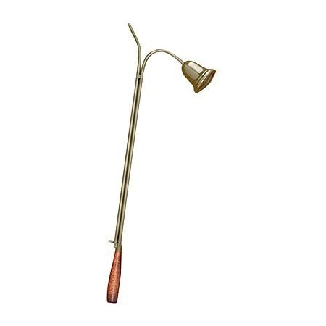 | Taper/Snuffer‐ A metal stick‐like object that may have wax inside used to light the altar candles, but we use lighters. It also has a bell-shaped snuffer used to extinguish (snuff) candles on the altar candles and the Paschal candle when lit. We keep it in the incense cupboard in the sacristy walkway.
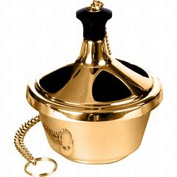 | Thurible (censer)‐ A metal receptacle attached to a chain that is used to burn incense. It is hung from a long chain so that it can be swung to disperse the incense smoke and aroma. The person who carries the thurible is called the thurifer. The thurible and boat are kept on a stand in the liturgical ministers’ sacristy or just behind the altar.

LESS COMMON TERMS FOR PLACES AND THINGS
These are quite common terms with special Masses or when a Bishop is presiding. For weekend Masses, these are terms that you may not encounter. Servers will need to be familiar with and have working knowledge of these when serving at special Masses.
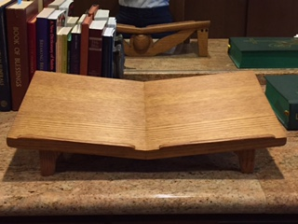 | Book Stand‐ A wooden support that props up the Roman Missal for the priest at the altar during the Eucharistic Prayer. We don’t use this at SPA unless a visiting priest or priest not on staff requests it.
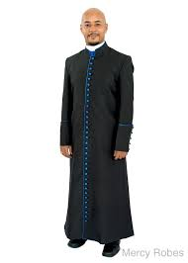 | Cassock- a close-fitting ankle-length garment worn especially in Roman Catholic and Anglican churches by the clergy and by laypersons assisting in services
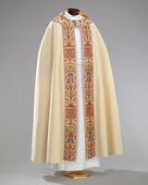 | Cope- A liturgical vestment, more precisely a long mantle or cloak, open in front and fastened at the breast with a band or clasp. It may be of any liturgical color. It is the vestment assigned to the celebrant, whether priest or bishop, for most functions except the Mass when the celebrant wears the chasuble instead. The cope is used, for example, in processions, in giving Benediction of the Blessed Sacrament, and the celebration of other sacraments outside of Mass. At SPA we use it during the Exposition of the Blessed Sacrament procession at the end of Holy Thursday and during Lessons in Carols.
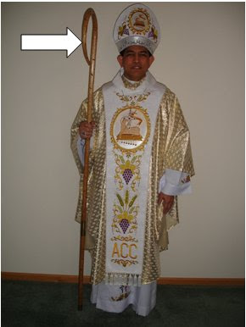 | Crozier- a hooked staff carried by a bishop as a symbol of pastoral office. During Mass, an altar server will manage the crozier.
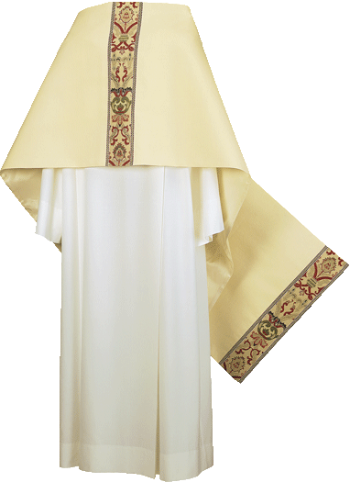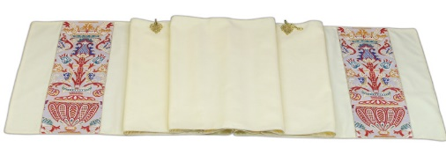 | Humeral Veil- One of the liturgical vestments. It consists of a piece of cloth draped over the shoulders and down the front, normally of silk or gold cloth, with a clasp at the neck. At the ends there are pockets in the back for hands to go into so that the wearer can hold items without touching them with their hands. It is most often used during the Exposition of the Blessed Sacrament on Holy Thursday and when the altar server wears them to hold the bishop’s crozier and mitre.
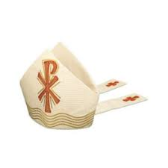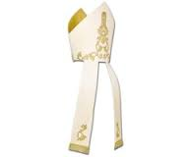 | Mitre- A tall headdress worn by bishops as a symbol of office, tapering to a point at front and back with a deep cleft between.
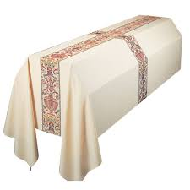 | Pall (mortcloth) ‐ a cloth that covers a casket or coffin at funerals. Commonly today palls are pure white, to symbolize the white clothes worn during baptism and the joyful triumph over death brought about by the Resurrection. The pall is often decorated with a cross, often running the entire length of the cloth from end to end in all four directions, signifying the sovereignty of Christ's triumph over sin and death on the cross.
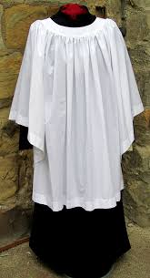 | Surplice- A loose white linen vestment varying from hip-length to calf-length, worn over a cassock by clergy, acolytes, and choristers at during Mass.

UNCOMMON TERMS FOR PLACES AND THINGS
You may never encounter these things here at SPA, but you may hear the terms—or you may see them used at another parish you may be visiting. At other parishes, some of these things are used more commonly than here at SPA.
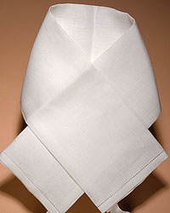 | Amice- a liturgical vestment made of an oblong piece of cloth usually of white linen and worn about the neck and shoulders and partly under the alb. It is usually worn whenever the alb does not completely cover the ordinary clothing at the neck. It is then tied around the waist. Many priests do not wear this anymore.
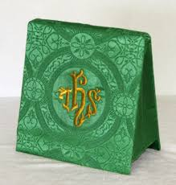 | Burse‐ An envelope type item made of cloth, matching the chalice veil used to hold the corporal cloth. It matches the liturgical color of the Mass being celebrated. We don’t use this at SPA.
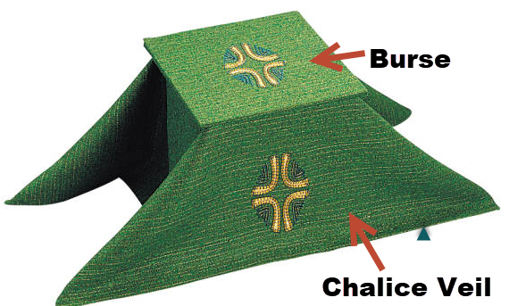 | Chalice Veil—A large cloth in the liturgical color of the day, used to cover the chalice before and after the Liturgy of the Eucharist. The color matches the liturgical color of the Mass being celebrated. We don’t use these at SPA, but some parishes still do.
 | Lunette (Luna): A thin, circular receptacle, with glass sides, metal circled with gold to hold the Sacred Host upright in the monstrance. It is a sacred vessel, having received the priest's blessing. It is sometimes called a luna.
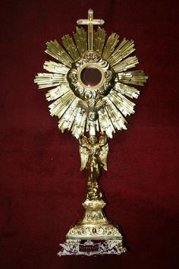 | Monstrance ‐ A large, ornate vessel used to hold the Blessed Sacrament during Adoration.
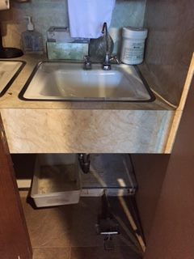 | Sacrarium ‐ A sink which drains directly into the ground. It is fitted with a cover and lock and is used for the disposal of the following: The sacred linen wash and rinse water, used holy water, used baptismal water, and blessed ashes. Ours, pictured here, is in the Priest Sacristy in the locked closet.

Set-up/Prep Photos
Prepared Altar  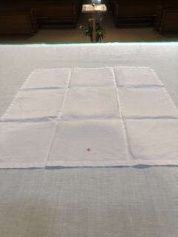  Cross at bottom  Note distance from bottom  of altar | Prepared Altar

Appendix 3. Altar Server Agreement

Altar Server Agreement
I wish to become a member of the SPA Altar Serving Ministry. God has called upon my family and me to play an especially significant role in the life of the Church and because of this we are willing to accept this responsibility and to make the necessary commitment. I and my parent(s)/ guardian(s) if under 18 have read the Altar Server Handbook/Training Manual and agree to adhere to the requirements stated in the Handbook.
As an SPA altar server, I promise to do the following:
- I will participate in the Mass through listening, praying, and singing.
- I will learn the proper actions of an altar server such as folding hands, sign of the cross, genuflections, bowing, walking, carrying the cross, silence, sitting and standing.
- I will continue to learn more about my faith and learn the elements of the Mass, why we do what we do at Mass, and key liturgical terms, objects, and places.
- I will be at church 15-20 minutes before the Mass for which I am signed up.
- I will serve at all Masses that I have signed up to serve. If I am unable to serve a Mass I have signed up for, I will delete my sign up on SignUpGenius and try to find a substitute.
- I will adhere to a dress code to show pride in my ministry.
- I will try to serve at least 4 Masses in a 3 month-period, and 2 of those times will not be at the 9:30 AM Mass.
- I know I may occasionally be asked to serve at weddings, funerals, Holy Week, or other special Masses, and I will try my best to serve when asked, assuming my schedule will allow for it.
- If something goes wrong during Mass, I will think about it for a moment, stay calm and then if possible and appropriate I will do what I can to fix the situation. I will always be willing to learn when things go well and even when they don’t. Remember: no one in the congregation will know that something went wrong. Just shake it off and move on.
- I will stay after Mass to debrief and to help clean up after Mass.
- I will make sure everything is put back in its proper place.
- I will hang my cincture in the proper place and place my alb in the gray hamper.
- Ima baptized Roman Catholic, and I have received the Sacrament of the Eucharist.
- All SPA students may serve at School Masses.
- All servers may serve at Family Grade Masses for their grade or their older/younger siblings.
- My parent(s)/guardian(s) and I will respect the privacy of the other servers’ contact information and will keep the contact information on the Altar Server Contact List Confidential. I promise to use this information only for purposes related to the Altar Server Ministry and Program.
- I will attend all required training and as many optional practices/trainings and social gatherings as possible.
- If I am unable to serve at a mass that I am signed up, I (or my parent/guardian) will delete my signup and always try to get a substitute.
For those under 18 years old sign here:
My parent(s)/guardian(s) and I have carefully read over the Handbook and this contract, and I have asked my family for their support in helping me fulfill these promises I have made to my parish community. They agree to support me and help fulfill my commitment (e.g., help to show up on time, find a replacement when I cannot serve a Mass for which I am signed up, be dressed appropriately, etc.)
Altar Server Name: ______________________________Signature: _____________________________
Parent/ Guardian Name: _________________________ Signature: _____________________________
Date______________
For those over 18 years old sign here:
I have carefully read over the Handbook and this contract, and I have asked my family and friends for their support in helping me fulfill these promises I have made to my parish community. They agree to support me and help fulfill my commitment.
Altar Server Name: ______________________________ Signature: ______________________________
Date: _______________

Appendix 4. Altar Server Shoe Examples

Acceptable
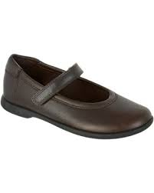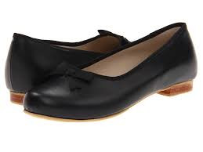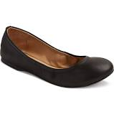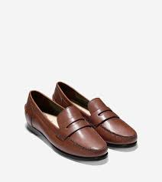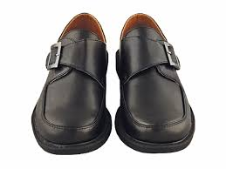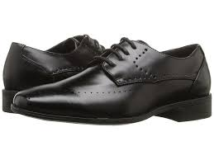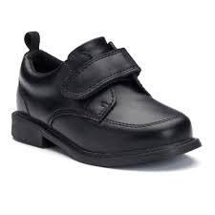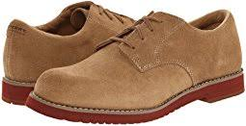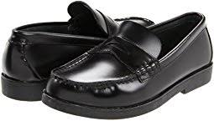
Not Acceptable
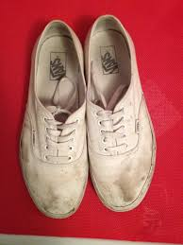

Appendix 5. SignUpGenius: How to Sign up and Manage Your Signups
We use Sign Up Genius for scheduling altar servers for all Masses. Here are some quick tips on Sign Up Genius.
- Signing Up. When you sign your child up, please click on the box, "Display an alternate name (like a spouse or child's name)." Then add their first name and last name and leave the comment section blank. The email will go to the person who is signing up, but the signup will show the name of the person serving. All changes to the signup and reminders will go to the adult email who signed up. Here is a screen shot:
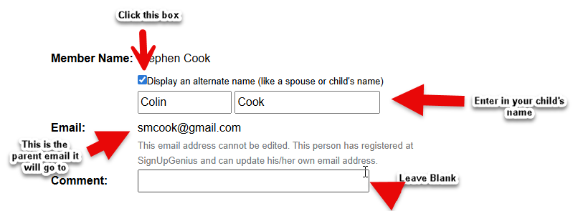
If you have multiple children, you can sign up one of two ways: A) You can sign them up individually displaying each of their names, or B) you sign them all up at once by clicking the quantity drop down menu and enter the number and adding all their names in the First Name Box.
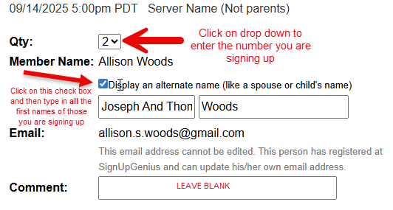
If the mass you want to sign up for is full you can join the Waitlist. It will say “All 4 slots full.” To the right is button that says, “Join the Waitlist.” Click on that and you will be added to the Waitlist in the order you joined. If someone deletes a sign up, the first on the Waitlist will automatically be added to the regular sign and an email will be sent to notify you. Everyone else on the Waitlist moves up. In this example if you clicked on the Join the Waitlist button you would be the 5th on the Waitlist.
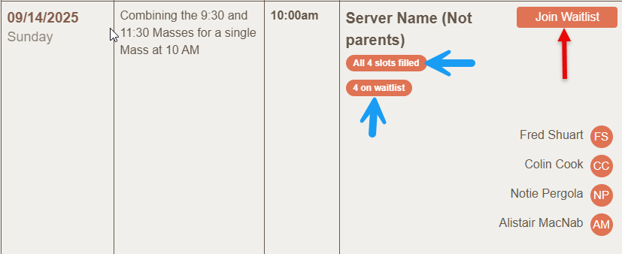
- Deleting your Sign Up. If you (teen and adult servers who sign themselves up) or your child cannot serve at the time they signed up, please go into the Signup Genius and delete the signup. It will need to be under the same email as the person who signed them up. Deleting the sign is important for several reasons: 1) I run reports for service hours and other reasons on who served. 2) I check the signups regularly and I need to know who signed up when. 3) I will get a notification that you deleted the sign up. You don't need to email me separately, and if you only email me and don't delete the signup then when I am looking at the schedule for an upcoming week, I might not remember that your child won't be there, or it requires me to go in and manually delete the sign up, so please do not email to let me know and not adjust the signup. For all these reasons, it is important that the signup is accurate and current. It would be very helpful if you could manage your signups through Signup Genius. Here is a screen shot of how to delete a sign up.
Here is how to delete your sign up:
  - If you signed up with an account (using an email and password), log in and click the title of the sign up under the section for “Items I've signed up for” to quickly view the option to edit/swap/or delete your sign up.
  - If you signed up without an account, you can go back to the sign up by following the link that was provided in your original invite, or you can go back to the confirmation email that was sent to you after you signed up. When you view the sign up, you'll see a link at the top that states, "Already signed up? You can change your sign up." Click that link to follow the steps to edit your sign-up slot.
  - If you still cannot locate the sign up, contact the me at jkozakowski@sp-apostle.org.
  - If you signed multiple children for the same mass and you used If you use method A in item 2, and one child cannot serve but the other(s) can, you need to delete only the one sign up. If you used method B (see #2 above) and one(or more) cannot serve but the other(s) can then you need to go into the Sign Up Genius and edit the sign up by changing the number in the quantity drop down menu and then deleting the first name of the child who cannot serve, making sure all those in the first name box will serve. I will get a notification of the change the email will go to the adult. Here is a screen shot:
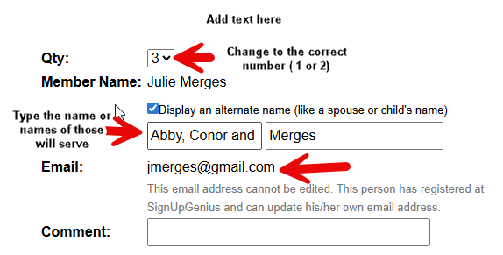
- Getting a substitute. Schedules change and things come up...no problem. Per the Altar Server agreements and handbook, if you or child cannot serve at a mass they signed up for, in addition to deleting the sign up in SUG, you must try and get a substitute. I would like to give a special shout out to the few families who always get a substitute--we appreciate it very much! The easiest way is to reach out to those you know who have children who are servers or to send an email to all server families and ask if their child can serve. You may use the Altar Server Roster contact information for this. Once you secure a substitute, please make sure that the parent of the sub signs their child who is subbing in up in the SUG. Now your child's name is not on the sign up and the substitute's name is on the sign up. Again, no need to email me as I will get notification, but if you want to email and let me know who the sub is that is great. If you try and cannot secure a sub, please email me and let me know ASAP.
- Swapping With Another Server. I have enabled the Swap feature, so if you cannot serve at the time you signed up and another server who is signed up at a time you a available to serve and is willing to swap times with you, you can do a swap as follows:
  - Log into your account
  - Find the sign up you need to swap under, “Items I've signed up for” and click to view the sign up. Locate the option to request a swap.
  - Select the person(s)/slot(s) you wish to swap slots with.
  - Submit your request for a swap. An email requesting a swap will be sent to everyone who is signed up in those slots.
  - If a participant accepts your request to swap, both will be notified of their new sign-up slots.

