Quick Reference Guide for Altar Servers 2025-2026
For more detailed information, please see the Altar Server Handbook

Sign up and Sub Procedures
- We will be using SignUpGenius to sign up for Masses.
- For the Regular Sign up: Please serve (at least) 4 Masses during each 3-month period. Two of those signups must be at a mass other than the 9:30 AM. When signing up, please consider signing for a Mass that has no servers signed up or regularly does not have servers.
- For Shadow training, Christmas, and Triduum/Easter we will always send a notice when one of the special signups is available.
- If there are no slots available at the time you want to serve, please check back frequently, as slots will open due to conflicts/schedule changes.
- If you are not already signed up to serve on a given weekend, and plan to attend Mass, please check the sign-up form, and if there are unfilled slots, please consider signing up for the mass you plan to attend.
- When not on the signed up to serve at a mass, but attending mass, please always check in with the priest to see if there is a need for you to walk on. Sometimes there are last-minute cancellations, no shows, or a server is late, and we need a substitute.
- If your plans change after you signed up, please go back to the SignUpGenius to delete or switch your sign up.
- See Appendix 5. in the Altar Server Handbook for more detailed instructions in using SignUpGenius.

Other Items:
- Please follow the Altar Server Rules and Dress Code specified in the Altar Server Handbook.

Before Mass:
- Arrive 20 minutes before mass begins (dressed appropriately, including shoes).
- Make sure alb reaches your ankles and cincture is secure around your waist (knot at left hip).
- Make sure the candles (if enough servers) and the cross are at the back of the church.
- Make sure the Prayer Missal (Excerpts from the Roman Missal) and the binder is on the Celebrant’s Table and the Roman Missal is on the Credence Table (behind the altar, below the tabernacle).
- Make sure the gifts (hosts in ciborium and cruet with wine) are on the Baptismal Font.
- Ask the celebrant if he needs help setting up.
- When not on schedule and attending Mass, please always check in to see if there is a need for you to walk on. Sometimes there are gaps in the schedule, last minute cancellations, no shows, or a server is late, and we need a sub.
- Wait at the back of the church with the Celebrant and other servers.
- Decide on your role: (1) cross, (2) candle (3), candle, (4) book. If you cannot decide, ask the priest of Altar Server Coordinator for help.
Introductory Rites:
Entrance Procession:
The altar servers line up in the following order:
- Incense (if being used at the Mass)
- Cross-hold as high as you can with 2 Candles, making sure they are even. Adjust for height difference. Stand right next to cross and walk as a unit.
- Book (If there is only one server, carry the cross. If there are only two servers, do cross and book with no candles).

After the music and singing starts, the altar servers begin to process at a normal walking pace into the church. All turn right at the lectern and proceed without pausing to the stands. DO not go to the center of the sanctuary make the right turn and go straight to the stands.
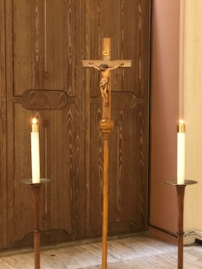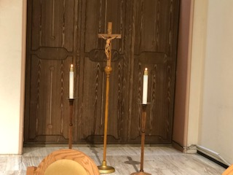
Book deep bows at the bottom of the stairs then goes to stand behind the chair to the right of the celebrant. Cross bearer stands behind the chair to the left of the celebrant. Candles sit in the altar server chairs against the wall.

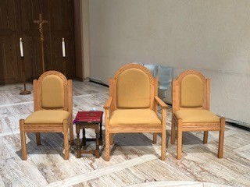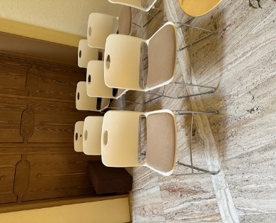
Book Bearer Celebrant Cross Candle Bearers and Others

PLEASE NOTE: IF THERE ARE CONCELEBRANTS, THEN SEATING IS ADJUSTED. IF THERE IS ONE, THEN BOOK SITS NEXT TO CELEBRANT AND CELEBRANT’S TABLE. IF ALL CHAIRS ARE OCCUPIED BY CONCELEBRANTS, THEN ALL SERVERS SIT WITH CANDLE BEARERS. BE SURE TO MOVE THE CELEBRANT’S TABLE AND BOOKS/BINDER TO THE CHAIRS BY THE WALL. THE BOOK BEARER APPROACHES FROM THERE TO HOLD BOOK OR BINDER FOR CELEBRANT.

Greeting:
- The priest begins the mass with the Sign of the Cross.
- The priest will welcome everyone and ask us to recall our sins and ask God for forgiveness. He may want the Excerpts from the Roman Missal here, so ask before Mass.
- The Gloria will be recited or sung.
- During the last verse (or line if spoken) of the Gloria (or after the Kyrie if the Gloria is omitted), the book bearer approaches the celebrant with the Excerpts from the Roman Missal for the Collect (Opening Prayer).
- When the priest is done with the prayer, the book bearer returns the Excerpts from the Roman Missal to the Celebrant’s Table, and all servers sit in their assigned chairs.

Liturgy of the Word:
- Listen to the First and Second Reading.
  - At the end of the second of the second reading, as soon as the Lector says, “the Word of the Lord,” the candle bearers remove candles next to the cross from the stands and go stand next to the chair to the right of the celebrant. If there is incense, the thurifer and boat holder will approach the celebrant while seated and kneel before him.
  - As soon as the Alleluia starts and the priest or deacon stands to go to the Book of Gospels and one candle steps in front to lead the procession to the altar and one candle is behind him, holding candles high. All three are moving in a single file line: candle, priest, candle. The one leading one stops in front of him and faces the altar, the priest stops and faces the altar to bow, and the candle behind stops and faces the altar.
  - The priest or deacon will bow (candles do not bow) and approach the altar and remove the Book of Gospels from the stand and then turn to face the congregation. When he does this, the two candles on each side turn and face the congregation as well, holding candles high.
  - The priest or deacon will then turn right to proceed to the ambo (the pulpit, not the lectern). The candle to his right leads the way to the front of the ambo (the priest or deacon will go to the ambo). The procession is also single file candle, priest, candle. The first candle bearer and goes down to the left of the ambo (as you face it). The second candle stands to the right of the ambo (as you face it). The two candle bearers hold the candles high in FRONT of the ambo and turn to face one another. Be sure to hold the candles straight.
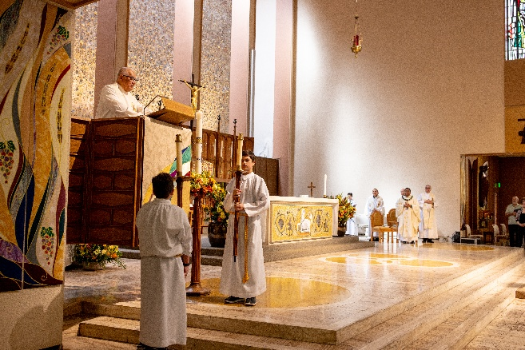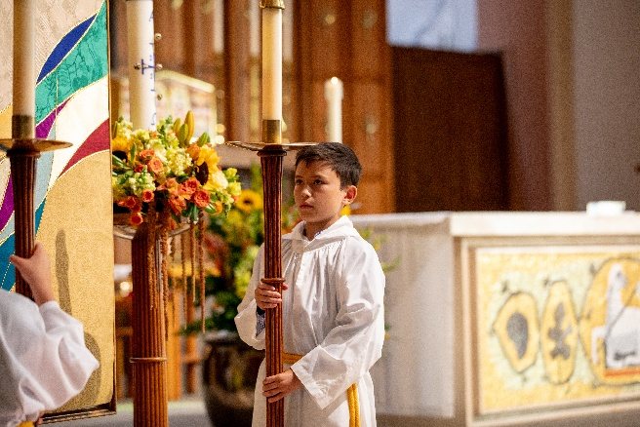

  - Note: If there is incense, the order of the processions is: candle, thurifer (incense), priest, candle. After all turn to face the congregation and the candle leads the way, the thurifer will lead the priest to the stairs of the ambo, and candles proceed to stand on either side of the ambo.
  - Raise the candles as high as you can, keeping them straight, and hold them on either side of the ambo, without blocking the priest or deacon as the Gospel is being read. If your arms get tired, just lower the candle. Just make sure the candles are the same height once you raise them.
  - The priest or deacon proclaims the Gospel and finishes by saying, “The Gospel of the Lord.” And the congregation responds, “Praise to you Lord Jesus Christ!” As soon as this is completed, the two candle bearers proceed to the book stand near the high pulpit and stand on either side of it. The priest or deacon will come down from the pulpit, kiss the book of Gospels, place it on the book stand and then bow. The candles then turn toward the back wall and proceed behind the reredos and place the candles in the stands from which they removed them. Sit in their chairs to listen to the homily.
  - All other servers remain standing at their chairs for the Gospel, and for the enthroning of the Gospel and do not sit for the Homily until the priest or deacon has bowed when placing the Book of Gospels in the stand. Then we sit for the Homily.
- After the Homily is the Creed (unless omitted) and the Payers of the Faithful.
- After the Homily, the celebrant will return to his chair and will likely sit for a moment. As soon as celebrant stands (or if he doesn’t sit), the book bearer approaches the priest with the binder to hold the binder for the Creed and Prayers of the Faithful.
- The priest concludes with a prayer and an announcement about our weekly gift. As the announcement for weekly gift is made, the cross and candle bearers grab the cross and the two lit candles from their stands (the candles on the either side of the altar are never moved or touched during mass) and proceed down the side aisle to the front of the baptismal font to prepare to lead the procession of the gifts. The order is: cross, two candles side by side, two gift bearers side by side. The book bearer places binder on the celebrant’s table and proceeds to prepare the altar. Please note: If the above is if there are 4 servers. If there are three servers: then after the announcement about the weekly the book/cross bearer, the book places the binder on the table and then grabs the cross along with the two candle bearers with the two candles and go back to lead the offertory procession of the gifts and the priest prepares the altar. If there are two servers, after the announcement, the server holding binder places the binder on the table then two candles go back and lead the offertory procession, and the priest prepares the altar. If there is one server, then after the announcement, place the binder on the table, and then grab the cross and go to the back to lead the offertory processing with just the cross. Priest prepares the altar.
- The congregation sits down.

Liturgy of the Eucharist
- When there are 4 servers, the book bearer prepares the altar as below.
- Sanitize your hands.
- Remove the plastic book stand that held the Book of Gospels (go around to the front of the altar if you cannot reach it from behind the altar) and place it on the shelf under the credence table behind the altar near the tabernacle.
- Grab the chalice/patent set up by placing your dominant hand on the stem of the chalice and placing your other hand on top of the corporal. Set it on the altar.
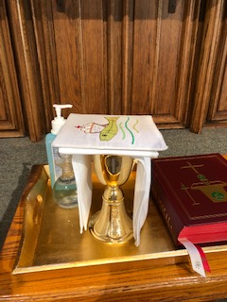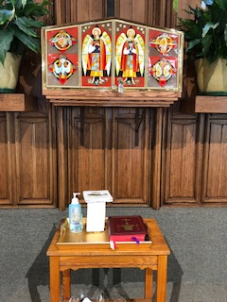
- Remove the chalice pall and place it to the right. The take the corporal and set it in the center of the altar, so that the book won’t sit on the corporal once it is placed. The corporals open in thirds and the cross is always at the bottom. Then place the patent with the large host to the right on the bottom right side of the corporal, with the empty chalice and purificator right next to it. The Roman Missal is placed open at the first green tab, page 381 and place it near the edge of the bottom of the altar and centered, with the top of the book on the corproal.
- If there is an empty ciborium on the credence table/tray leave it and then bring it to the priest at the Lamb of God. If there is an extra ciborium with hosts in it, then place it on the upper left hand corner of the corporal with the lid remaining on.
- If there is a pyx on the tale, place the closed pyx on the center corporal and open the pyx.
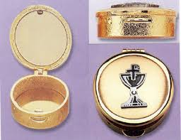

- Below is what a prepared altar looks like:
Corporal spread out center of altar with cross at bottom

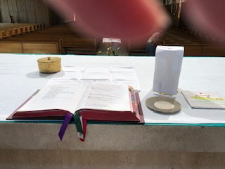
Chalice covered with purificator or laid next to it on altar.
Extra ciborium if contains hosts—you need to place when you prepare the altar; otherwise, if it is empty leave and hand to priest at Lamb or God. If no extra on credence table, then nothing to do.

Roman Missal placed here an open to page 381 Paten with host Chalice pall

- When finished with preparing the altar, go to the celebrant’s chair and go with the priest and to receive the gifts per below. If the priest has already moved to the center of the sanctuary, then join him on his right, careful not to cross in front of the priest).
- The priest will then stand and go to the center of the sanctuary to receive the gifts.
- The server who prepared the altar will go up and stand on the right side of the priest.
- When the priest rises to receive the gifts, the cross and candle bearers (or just cross) will then lead the gifts, holding the cross/candles high just like with the entrance. Walk at a normal pace forward, all going to the right of the lectern and proceeding to the center in front of the priest and server bow their head when they get in front of the priest and then proceed to put the cross and candles in their usual stands. They will then go to the altar servers’ table where one server will get the water pitcher and the other server the handwashing bowl and towel, placing the towel over your left forearm.
- The priest will accept the gifts, the wine cruet first, and then the ciborium (sometimes he takes them together) and hands the wine cruet to the server. All bow to gift bearers before proceeding to the altar with the gifts.
- The server should remove the top of the wine cruet and place it on the tray on the credence table and remove the top of the water cruet and grab the wine cruet in their right hand and the water in their left hand with the handles facing OUT so the priest can grab the each by the handle. Proceed to the priest’s right side and as soon as he puts the host down be prepared to hand him the wine cruet and while he pours the wine, transfer the water cruet from your left hand to your right. Receive the wine cruet in back from the priest with your left hand and hand the water cruet to priest handle facing him with your right hand. Stay in place, and after he places the water in the wine receive the water cruet in your right hand and then place both cruets on the tray and recap as prays over the gifts.
- As soon as the server steps aside to place the cruets on the credence table, the candle bearers with the water pitcher and hand washing bowl/towel should approach the altar and stand just to the right of the while the priest is praying over the gifts and bows.
- The server with bowl and towel on his/her left arm holds the bowl under the priest’s hands, and the server with the water cruet pours the water on the celebrant’s hands. Some want less water than others. Fr. Gil will always want the entire amount of water in the small pitcher poured.
- The priest will dry his hands with the towel and place it back on your arm. These two servers place the bowl, towel, and water cruet on the servers’ table and then join the other two servers standing at the bottom of the steps on the left side of the altar.
- If there is incense at the Mass, everything is the same except for the timing of the handwashing, which follows the incensing of the gifts and priest—see AS Handbook for more details.
- Put everything back on the altar servers’ table, go stand with the other 2 servers at the base of the side steps to the altar (closest to the statue of St. Paul and the Ambo/Pulpit).
- The priest will invite the congregation to stand for Eucharistic Prayer.
Eucharistic Prayer:
  - The priest then begins with preface.
  - Holy, Holy, either sung or recited.
  - The server who is going to ring the bells for the Epiclesis and the Elevation, picks up the altar bells during the Sanctus (Holy, Holy song).
  - The bells are rung as roll, or a long continuous ring. Each roll has rings that sound like da-da-da-da. Please listen to this recording very carefully on how to ring the bells at all three places in the Eucharist Prayer.
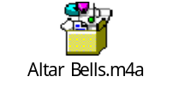
  - The bells are rung the first time during the epiclesis (or the invocation of the spirit), when priest brings his hands down and holds them over the bread and wine, just before the consecration, and invokes the spirit. You will use the visual cue of when the priest brings his hands over the bread and wine to start ringing the bells with ONE Roll (not a single ring, but a single roll). He will invoke the spirit while the bells are ringing. Be sure to stop ringing before the consecration (when he makes a cross over the bread and wine). Don’t rush the ringing of the bells. Here is a photo of your visual cue to start ringing at the epiclesis:

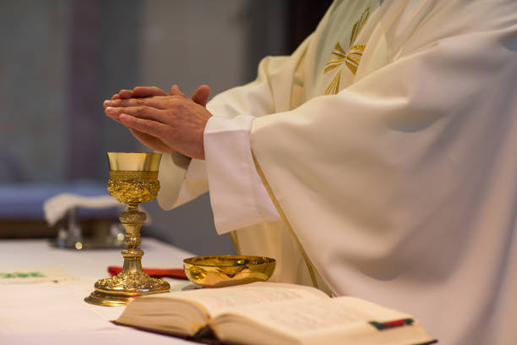

  - The priest will first pick up the host, to be consecrated, by saying “Take this, all of you, and eat of it, for this is my Body, which will be given up for you.” The priest will raise (elevate) the Body of Christ to show the congregation. You wait until the host is fully elevated and being shown to the congregation to begin ringing the bells with three rolls, ensuring there is a pause between each roll. Do not start ringing when he finishes the words or when he starts to elevate the host. Wait until it is fully elevated and being shown to the congregation. Don’t rush the ringing of the bells. Ring first roll. Pause. Second roll. Pause, Third roll. Remember each roll is a long ringing that sounds like da-da-da-da. The priest will place the host back on the patent and then kneel or genuflect. All servers bow deeply in unison with the priest and each other, the server with the bells taking care not to let the bells ring while bowing. Here is your visual cue of when to start ringing:

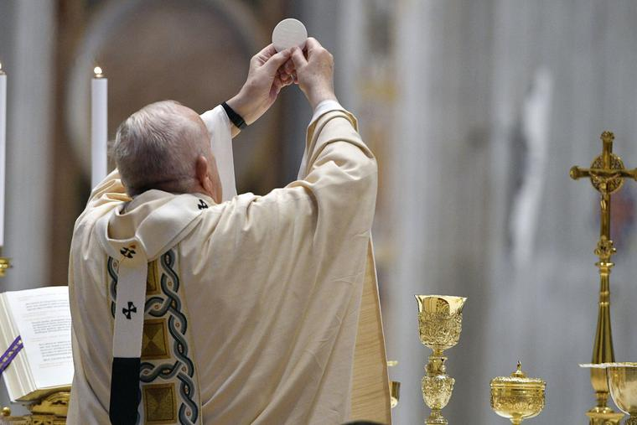

  - The priest will then pick up the chalice and say, “Take this, all of you, and drink from it, for this is the chalice of my Blood, the Blood of the new and eternal covenant, which will be poured out for you and for many for the forgiveness of sins. Do this in memory of me.” He will raise the chalice, and just like with the host, when it is fully elevated and being shown to the congregation, slowly ring the bells with three distinct rolls. Here is your visual cue to ring the bells with the chalice elevation.

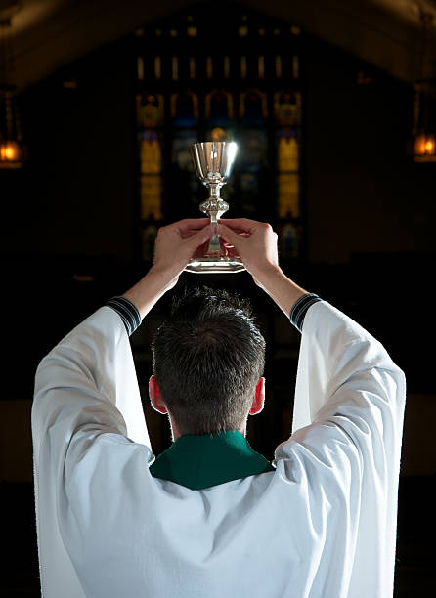
  - We all bow deeply in unison with the priest and each other, again careful not to ring the bells. The server then returns the bells to their spot on the altar.
Please listen to the audio recording above.

  - The priest will proclaim the mystery of faith. Everyone sings the memorial acclamation and the server places the bells back.
  - Everyone recites the Our Father (stay standing at the stairs of the altar).
  - Sign of Peace.
  - After the Sign of Peace and as the Lamb of God begins, servers sanitize hands and then move up the stairs to the back of the altar to wait for communion. Be sure to move toward the center to make room for lay Eucharistic Ministers.
Communion:
- The Lamb of God will either be sung by the choir or recited by the priest, the congregation will join in.
- Eucharist ministers and altar servers are lined up to receive communion.
- The priest will distribute the Body of Christ to all on the altar in the hand. Immediately consume by lifting mask and then sanitizing hands again.
- After receiving the Blood of Christ, the EMs will proceed to their stations.
  - Once the altar servers have received Eucharist and the EMs have left the altar, one server (candle) remove the Missal from the altar and place it back on the credence table.
  - Another server (candle) removes all ciborium lids except for 1 and places them on the credence table.
  - If there is a pyx on the altar, please leave it on the center corporal.
- Two servers (book and cross) then go to their chairs and remain standing in front of their chairs.
- The two candle bearer servers stand at the bottom of the side steps to the altar, near the reredos—one on each side of the altar.
- Book bearer leaves the red Excerpts from the Roman Missal on the celebrant’s table and the cross grabs the binder for the announcements.
- DURING COMMUNION, DO NOT GO INTO THE PRIEST OR LITUGICAL MINISTERS SACRISTIES UNLESS YOU ARE ILL OR NEED TO USE THE RESTROOM OR GET A TISSUE.
- Servers should always remain in the sanctuary unless performing duties or they have been asked by another minister to retrieve something.
- Once the priest is done distributing communion, he will return to the altar and all the Eucharistic Ministers will come to him with their ciboria.
  - The two candle servers who have been standing follow the priest and EMs up the stairs to the altar.
  - The priest will consolidate all remaining hosts from the ciboria into one.
  - One server needs to be standing by to take the empty ciboria(um) from the priest and place it/them on the credence table.
  - The priest will then place the lid on the altar on the ciborium with the consecrated hosts and then turn to place it in the tabernacle. When he approaches the tabernacle, the two servers on the altar turn and face the tabernacle until the celebrant has secured the ciborium in the tabernacle and locked it, at which time he will bow or genuflect, and the two servers join him in bowing or genuflecting and then turn around. One server returns to his/her chair and the other remains on the altar. The remaining server needs to remove the cap from the water cruet and be ready.
  - The priest will then purify the chalice, where he will immediately the water from the credence table. He may want you to hand it to him or he may want you to pour a small amount in chalice. Once the water is in the chalice, the server should return the water cruet to the credence and cap it. Meanwhile, the priest will swirl the water in the chalice and consume it, then clean it with the purificator.
  - He will then place the purificator over the chalice then the paten on the purificator. He will carefully fold the corporal and place it on the paten, then place the chalice pall and either hand it to the server, where you take it with hand on the stem of the chalice and one on top of the chalice pall. He might leave it on the altar and step aside for the server to then take the set up by the stem of the chalice in one hand and the other hand on top of the chalice pall. Either way, once the server has it, he/she places it on the tray on the credence table. Both the server and celebrant face the tabernacle and bow while sanitizing their hands.
  - The priest returns to the celebrant’s chair and the server returns to his/her chair against the wall next to the other server and all then sit when the priest sits in his chair.
  - As soon as you sit, book bearer picks up the Excerpts from the Roman Missal and opens to the page for the Prayer after Communion, remaining seated until the priest stands.
  - At the same time, while seated, the cross bearer opens the binder to the announcements.
  - When the priest stands after sitting, and says, “Let us pray,” the book bearer approaches the celebrant with red book, Excepts from the Roman Missal, open to Prayer after Communion for that Sunday (it is the same page as the opening prayer and marked by a ribbon).
  - At the end of the Prayer after Communion, close the Excerpts from the Roman Missal and place it on the celebrant’s table, unless the priest plans to offer a solemn blessing at the end of mass after the announcements. Please confirm this before Mass.

Concluding Rites:
- As soon as book bearer moves aside with the Missal, the cross bearer steps in with the binder open to the announcements. Some priests will want you to hold the binder for the announcements; some will not and will grab the binder from you and then place it on the table when finished. If you are holding the binder for announcements, when concluded step back in front of your and close the binder, ready for the final blessing and dismissal.
- Usually, the celebrant will offer the final blessing and dismissal without the book or binder.
- If there is a special blessing, it may be in the book or binder and the priest will let you know to stand aside while announcements are read.
- Pay close attention for cues (such as “Let us pray…” “Bow your head and pray for God’s blessing…” a look over toward you) from the celebrant and always check in with the celebrant before Mass.
- If there is no special blessing, the priest will then conclude the Mass with the Sign of the Cross (no need to hold the book).
- The deacon or priest will offer the dismissal, which the congregation responds with, “Thanks Be to God!”
Recession
- The cross bearer and candle bearers grab the cross and candles from their stands and proceed to base of the steps in front of the lectern, while the choir starts the final song.
- The cross lines up at the first pew facing the altar and raises the cross very high (as high as you can comfortably hold it)—back to congregation.
- The candles line up, right next to the cross facing the altar—back to congregation.
- The book bearer (carrying nothing) lines up in front of the candle facing the altar—back to the congregation.
- The priest will then go to the altar and reverences it and then and come to some place in front of the altar and face the altar, back to congregation. Some will come to step just above where the servers are; others will stand at the top of the steps.
- All servers pay close attention to the celebrant. The priest will bow and turn. The book bearer server carrying nothing will bow at the same time as the priest and all (cross, candles, book bearer) turn around when the priest turns around and the cross leads the recession out.
- If there are more than 4 servers, then all is the same except all those not carrying the cross or candles, line up in a straight line along the bottom step and all bow when celebrant bows. The cross leads us out followed by candles, and the servers from each end of the line go two together, followed by the next two from each side, followed lastly by the server(s) in the middle. In other words, you recess out from the outside of the line in with the person in the center of line going last.
After Mass
- After the sending song has finished, servers then return the cross and candles to their stands on the altar. Book bearer grabs the candle snuffer from the Incense Cupboard in the sacristy hallway and uses the snuffer to extinguish all candles. FOR SAFETY, PLEASE DO NOT BLOW OUT THE CANDLES—USE ONLY THE SNUFFER.
- Two servers grab the used hand washing bowl, pitcher, and towel from the altar servers table and all servers return to the Liturgical Ministers’ sacristy.
- All servers remove their cinctures and hang them up, then remove their albs and place them in the gray laundry hamper—please do not hang them up after wearing them.
- Servers help clean up. Please place the used hand washing towel in the hamper in the priests’ sacristy.
- Wash and dry the hand washing bowl, pitcher, and place back in the vessels’ cupboard.
- Before leaving, please check in with the altar server coordinator or committee member (if present) or celebrant for a quick debrief and to see if any additional help is needed.
Reminders
- When you are standing or sitting, and not doing anything, keep your hands folded in your lap or in the praying position. Do not play with, fiddle with, or swing your cincture.
- PAY ATTENTION, especially to the priest, they may call you over.
- PLEASE DO NOT talk or argue when you are on the altar. If you are not sure or need help during mass ask a senior server, or the celebrant.
- Please review the Liturgy Guide and Names and Places of Things documents for more information on basic liturgy and for a glossary of terms with photos for reference.
- If you need to use the restroom, or get a tissue, or a drink of water in hot weather, use the facility in the liturgical minister sacristy.
- If you are assigned to serve, please follow the Dress Code. Walk-on servers will not be held accountable to dress code.
- For details and procedures, please refer to Altar Server Handbook from your training.
- Please review Altar Server Shoe Examples for acceptable and not-acceptable shoes.
PLEASE NOTE: EXCEPT AS NOTED THESE PROCEDURES ARE FOR 4 OR MORE SERVERS. IF THERE are 3, 2, OR 1 ADJUSTMENTS THROUGHOUT NEED TO BE MADE AND SERVERS WILL SERVE IN MULTIPLE ROLES. THE RECESSION IS ALWAYS THE SAME AS THE PROCESSION. FOR EXAMPLE, IF YOU ARE ALONE PLACE THE HANDWASHING NOWL, TOWEL AND WATER PITCHER UNDERNEATH THE CREDENCE TABLE. IF THERE ARE TWO OR MORE IT GOES ON THE ALTAR SERVER TABLE BEHIND THE REREDOS.
WHEN THERE ARE MULTIPLE CONCELEBRANTS THEN ALL SERVERS SIT IN THE SERVER CHAIRS AGAINST THE WALL AND THE CELEBRANTS TABLE IS MOVED OVER THERE WITH THE BOOK AND BINDER. THE BOOK BEARER WILL THEN ALWAYS GRAB THE BOOK FROM THE TABLE AND APPROACH FROM BEHIND AND STAND IN FRONT OF THE CELEBRANT.
THANK YOU for your service. Learn and have fun! The more you serve, the more comfortable and confident you will be, the more you will learn and the more fun you will have in your ministry.

