SignUpGenius: How to Sign up and Manage Your Signups
We use Sign Up Genius for scheduling altar servers for all Masses. Here are some quick tips on Sign Up Genius.
- Signing Up. When you sign your child up, please click on the box, "Display an alternate name (like a spouse or child's name)." Then add their first name and last name and leave the comment section blank. The email will go to the person who is signing up, but the signup will show the name of the person serving. All changes to the signup and reminders will go to the adult email who signed up. Here is a screen shot:
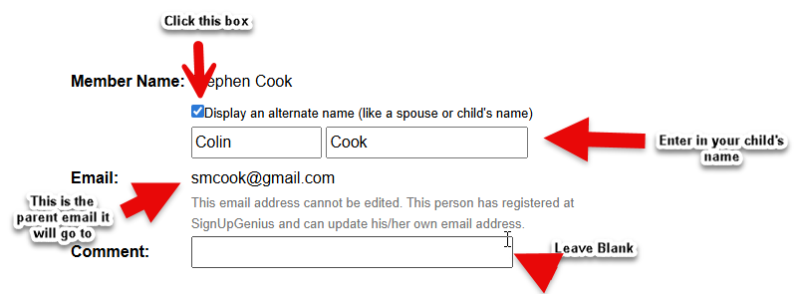
If you have multiple children, you can sign up one of two ways: A) You can sign them up individually displaying each of their names, or B) you sign them all up at once by clicking the quantity drop down menu and enter the number and adding all their names in the First Name Box.
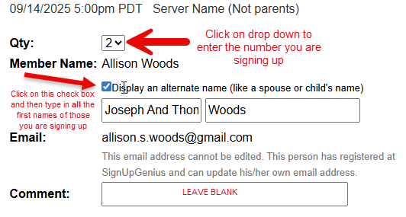
If the mass you want to sign up for is full you can join the Waitlist. It will say “All 4 slots full.” To the right is button that says, “Join the Waitlist.” Click on that and you will be added to the Waitlist in the order you joined. If someone deletes a sign up, the first on the Waitlist will automatically be added to the regular sign and an email will be sent to notify you. Everyone else on the Waitlist moves up. In this example if you clicked on the Join the Waitlist button you would be the 5th on the Waitlist.
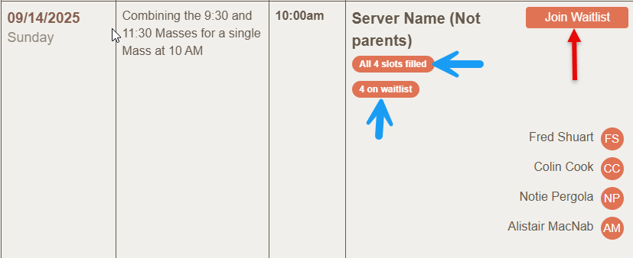
- Deleting your Sign Up. If you (teen and adult servers who sign themselves up) or your child cannot serve at the time they signed up, please go into the Signup Genius and delete the signup. It will need to be under the same email as the person who signed them up. Deleting the sign is important for several reasons: 1) I run reports for service hours and other reasons on who served. 2) I check the signups regularly and I need to know who signed up when. 3) I will get a notification that you deleted the sign up. You don't need to email me separately, and if you only email me and don't delete the signup then when I am looking at the schedule for an upcoming week, I might not remember that your child won't be there, or it requires me to go in and manually delete the sign up, so please do not email to let me know and not adjust the signup. For all these reasons, it is important that the signup is accurate and current. It would be very helpful if you could manage your signups through Signup Genius. Here is a screen shot of how to delete a sign up.
Here is how to delete your sign up:
  - If you signed up with an account (using an email and password), log in and click the title of the sign up under the section for “Items I've signed up for” to quickly view the option to edit/swap/or delete your sign up.
  - If you signed up without an account, you can go back to the sign up by following the link that was provided in your original invite, or you can go back to the confirmation email that was sent to you after you signed up. When you view the sign up, you'll see a link at the top that states, "Already signed up? You can change your sign up." Click that link to follow the steps to edit your sign-up slot.
  - If you still cannot locate the sign up, contact the me at jkozakowski@sp-apostle.org.
  - If you signed multiple children for the same mass and you used If you use method A in item 2, and one child cannot serve but the other(s) can, you need to delete only the one sign up. If you used method B (see #2 above) and one(or more) cannot serve but the other(s) can then you need to go into the Sign Up Genius and edit the sign up by changing the number in the quantity drop down menu and then deleting the first name of the child who cannot serve, making sure all those in the first name box will serve. I will get a notification of the change the email will go to the adult. Here is a screen shot:
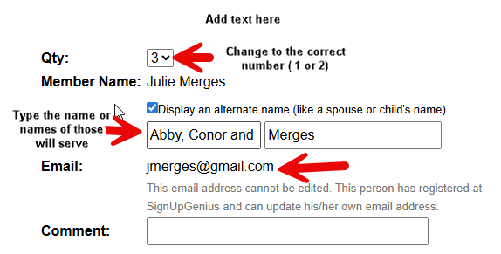
- Getting a substitute. Schedules change and things come up...no problem. Per the Altar Server agreements and handbook, if you or child cannot serve at a mass they signed up for, in addition to deleting the sign up in SUG, you must try and get a substitute. I would like to give a special shout out to the few families who always get a substitute--we appreciate it very much! The easiest way is to reach out to those you know who have children who are servers or to send an email to all server families and ask if their child can serve. You may use the Altar Server Roster contact information for this. Once you secure a substitute, please make sure that the parent of the sub signs their child who is subbing in up in the SUG. Now your child's name is not on the sign up and the substitute's name is on the sign up. Again, no need to email me as I will get notification, but if you want to email and let me know who the sub is that is great. If you try and cannot secure a sub, please email me and let me know ASAP.
- Swapping With Another Server. I have enabled the Swap feature, so if you cannot serve at the time you signed up and another server who is signed up at a time you a available to serve and is willing to swap times with you, you can do a swap as follows:
  - Log into your account
  - Find the sign up you need to swap under, “Items I've signed up for” and click to view the sign up. Locate the option to request a swap.
  - Select the person(s)/slot(s) you wish to swap slots with.
  - Submit your request for a swap. An email requesting a swap will be sent to everyone who is signed up in those slots.
  - If a participant accepts your request to swap, both will be notified of their new sign-up slots.

